⚖️ Statement of Case – Housing Disrepair and Negligence
Claimant: Mr. S. P. Cordell Property: 109 Burncroft Avenue, Enfield Tenure: 11 August 2006 – 14 November 2022 Managing Authority: Enfield Council / Enfield Homes Nature of Claim: Breach of duty of care, prolonged housing disrepair, negligent mismanagement, emotional and physical harm caused by council inaction.

🧠 Executive Summary
Over a 16-year tenancy, Mr. Cordell was subjected to persistent and unresolved housing disrepair. Despite hundreds of complaints, photographic evidence, personal injury, toxic exposure, and structural hazards, Enfield Council failed to uphold basic duties of care, repair, safety, and tenant protection.
The flat at 109 Burncroft Avenue:
- Was structurally unsound and hazardous for extended periods
- Had no working heating for multiple years
- Contained toxic damp, mould, and damaged walls and flooring
- Repeatedly exposed the claimant to carbon monoxide due to faulty alarms
- Invited neighbour hostility due to leaked Council documents and false accusations
- Led to long-term emotional, physical, and reputational harm
All failures are detailed in Mr. Cordell’s full Victim’s Statement, which this Summary Narrative accompanies.

📆 Timeline of Key Failures and Events
Year | Breach / Incident | Legal Relevance
2006 | Initial damp, mould growth; no effective ventilation | Breach of fitness standards
2007 | Industrial humidifier used; extensive damage to walls | Admitted repair need, prolonged exposure
2008 | Floor collapse injury; undiscovered leak; heating shut down | Personal injury; unsafe premises
2009 | No heating, insecure windows, unfit sleeping conditions | Violation of repair duty
2010 | Delayed ventilation install (3-year delay) | Failure to act in reasonable time
2011–2013 | Heating unresolved; wrongful police accusation adds trauma | Emotional harm and negligence
2014 | Carbon monoxide poisoning; neighbour aggression | Breach of health and safety
2015 | Council falsely claims tenant caused pipe damage | Defamation and breach of candour
2016 | Wrongful blame for water pressure issues | Ongoing slander and false reporting
2017–2020 | No progress; increasing mould, failed window seals | Continued duty breaches
2021 | Kitchen rot, draft intrusion, warping floors | Unfit for habitation
2022 | External leaks ignored; final year ends with unresolved hazards | Flat uninhabitable upon exit

📌 Breaches of Statutory Duty
A. Housing Act 1985 / 2004 / Homes (Fitness for Human Habitation) Act 2018
- Property failed to meet basic standards of habitability across multiple categories.
- Repairs delayed without lawful justification; known hazards not resolved.
B. Defamation and Data Handling Breaches
- Internal false accusations about pipework and noise complaints were leaked externally.
- Resulting harassment from neighbours led to emotional distress and reputational harm.
C. Breach of Duty of Candour
- Council misrepresented facts to contractors and the claimant.
- Refused to admit false claims even when disproven by surveyors and workmen.
D. Negligence and Personal Injury
- Collapse of flooring caused physical harm; no timely resolution or support.
- Carbon monoxide exposure resulted from failed safety installations.
E. Emotional and Psychological Harm
- Chronic exposure to toxic conditions, defamation, neighbour hostility, and structural insecurity.
- Loss of dignity, privacy, and domestic peace over 16 years.

📎 Supporting Evidence
- Victim’s Statement (2006–2022): 160-point record including photographs, correspondence, witness testimony, medical impact, timeline tables.
- Exhibits: Photos, letters, emails, audio/video logs (Diary), National Grid reports, surveyor assessments.
- Named Council Staff: Dawn Allan, Neville Gray, multiple surveyors and engineers acknowledged the issues.
- Third Party Verifications: Thames Water, National Grid, Council contractors, and private plumbers confirmed claimant was not at fault.

🧱 Final Position
The combined records demonstrate systemic failure. Enfield Council:
- Ignored statutory obligations
- Failed multiple repair deadlines
- Disseminated false accusations
- Repeatedly deflected accountability
- Abandoned a tenant to suffering
The legal position is one of clear liability for:
- Negligent mismanagement
- Breach of statutory repair obligations
- Failure to provide safe, habitable accommodation
- Reputational and emotional harm

📄 Victim’s Statement – Personal Account of Disrepair and Harm
Claimant: Mr. S. P. Cordell Property: 109 Burncroft Avenue, Enfield Timeframe Covered: 11/08/2006 – 14/11/2022

🛠️ Section A – Disrepair Issues and Mismanagement by My Housing Team

A.1 Timeline and Overview
- Start Date of Tenancy: 11/08/2006
- End Date of This Complaint Period: 14/11/2022
I, the claimant, entered into tenancy at 109 Burncroft Avenue on the 11th of August 2006, where over the course of 16 years I was exposed to dangerous and deteriorating housing conditions. These issues were repeatedly raised with Enfield Council, Enfield Homes, and the Safer Neighbourhood Watch teams — yet those responsible failed in their obligations to guarantee me security of tenure and a safe, habitable home.
Despite numerous reports and clear evidence, the property remained in an unfit state, with qualifying repairs ignored across the timeline of my tenancy. The problems were never fixed properly — they remain today.

A.2 Discovery of Damp and Mould (2006)
- When I first moved into the flat in August 2006, it appeared freshly painted by Enfield Council. Initially, it didn’t seem to be in poor condition.
- However, straight away I noticed a strong, overpowering damp smell. I assumed it was due to fresh paint and poor ventilation, and expected it would pass.
- Within months, I became used to the pungent odour — but then saw toxic black mould spreading across the walls and ceilings.
- This mould began destroying my personal belongings and compromising my health. It was not due to my actions — the damage came from the property itself.

A.3 My Response and Early Complaints
- I began documenting the problem myself by taking photo evidence and contacting the relevant authorities to report my suffering.
- These photographs are included in the table at the bottom of this document, marked Exhibit ****.
- Myself and my support network reached out to Enfield Council and associated companies via telephone, clearly explaining the damage to my belongings and the risk to my health.

A.4 Council’s Inadequate Response
- Surveyors attended the property and stated the issue was poor air circulation.
- However, staff on the phone told me the problem was “condensation” and blamed me for not opening the windows enough.
- During winter, opening windows continuously was not feasible.
- The windows were double-glazed and had built-in ventilation vents, which I always kept open — yet the damp continued to grow.
- Despite doing everything the Council instructed, the problem worsened.
- I scrubbed the walls and ceilings at least once a week, but the mould came back every time. This cleaning became a regime I had no choice but to follow.
- Eventually, the Council closed off my bedroom entirely — leaving the mould to fester, while I was forced to sleep in the front room of a one-bedroom flat.
- The bedroom became unusable due to the extent of the damage.

A.5 Health Impact and Emotional Toll
- No matter what room I tried to live in, the damp made me ill in more ways than one.
- The Council continued to insist it was my fault, attributing it to condensation, and refused to help me.

A.6 Boiler Failures
- During this time, the main motherboard in my boiler repeatedly failed and had to be replaced by Enfield Council.
- Their engineers explained that the boiler suffered from low water pressure and gave me instructions on how to keep it topped up — which I followed meticulously and made part of my routine.

A.7 Soundproofing Failures (2006 Onwards)
- Within weeks of moving into the flat, I noticed severe soundproofing issues.
- Conversations from neighbouring homes were clearly audible, creating a total lack of privacy and undermining any sense of personal space.
- The flat was not fit for private family life. This wasn’t just unpleasant — it was intolerable.
- The Council’s own housing estate manager confirmed that the flats at Burncroft Avenue were not up to ISO standards.

📄 Victim’s Statement – Year 2007
Claimant: Mr. S. P. Cordell Property: 109 Burncroft Avenue, Enfield

🔧 Continued Disrepair and Hazardous Living – Year Two of Tenancy
- By the year 2007, Enfield Council continued sending out different surveyors with each complaint. No repair works began to eliminate the high-risk damp disrepair issue, which persisted, isolated entire rooms, and grew in its own dormancy.
- Within a year, 109 Burncroft Avenue had become a toxic hell, and yet Enfield Council staff left me to live inside of it. My photographic exhibits evidence this reality.
- The smell created by the humidity of the damp and mould couldn’t be captured by pictures — but anyone who’s experienced extreme damp or has professional knowledge of these conditions would understand. The air inside was saturated with allergens and toxic spores, making the environment physically harmful and emotionally unbearable.
- Each visiting surveyor confirmed the obvious: a) The flat had bad air circulation, leading to poor ventilation and ideal conditions for fungal spores to flourish.
- Eventually, one of the surveyors — believed to be the final one for that year — agreed that works were necessary. He stated that the walls would be stripped back to brick, treated, and re-plastered.
- The proposed works also included installing ventilation systems into every room via the windows and walls.
- The surveyor explained that a large industrial humidifier would be placed in the bedroom (the worst-affected room) to extract unwanted water before wall treatment could begin.
- I agreed to this plan, and works were scheduled to proceed.
- A few days later, Enfield Council staff arrived with the industrial humidifier and installed it inside the bedroom. Before leaving, they provided me with maintenance instructions and said it would need to run for around three months.
- The humidifier began removing water from the interior and exterior walls — including the flat’s foundations.
- My only access to the bedroom was to empty the water bucket collected by the humidifier.
- Early on, the bucket filled multiple times a day — on average, three times daily. This task became part of my life.
- Although I managed the machine carefully and avoided accidents, maintaining it for such a long time was difficult and demanded constant attention. I had to remain present at specific times each day, continuing until Enfield Homes staff finally began their repair works.
📄 Victim’s Statement – Year 2008
Claimant: Mr. S. P. Cordell Property: 109 Burncroft Avenue, Enfield
🕳️ Sinkhole Injury and Water Leak Discovery
- In the early months of 2008, I was still collecting water from the industrial humidifier. On one trip to empty the bucket, something shocking happened.
- As I stepped into my front hallway, bucket in hand, heading for the bathroom, my foot sank into the floor. It disappeared into the ground.
- The sharp pain almost caused me to drop the bucket and cry out, but I knew if I spilled the water, I’d have to clean it up. I placed the bucket safely down and looked to inspect the damage.
- My foot was grazed and bruised — bleeding from impact with the broken chipboard. If not for the shallow concrete below, the injury would’ve been far worse.
- I called my mother, shaken and in pain, to explain what had happened.
- She immediately advised me to contact Enfield Council, warning me that a collapsing floor indicates a serious structural hazard.
- I phoned the Council straight away. To my shock, a surveyor arrived within an hour.
- After a brief visual inspection, the surveyor agreed with me: emergency disrepair works were needed immediately. He left the flat making a call to arrange urgent repairs.
- That same day, another worker arrived and began lifting the dangerous floorboards from the bedroom, bathroom, and hallway.
- While lifting boards, the worker discovered that the heating system had fractured a copper pipe beneath the floor, connecting between the bedroom and bathroom.
- The fracture had created a water leak, likely years old, worsening over time and hidden until the flooring collapsed.
- Based on the extent of the water damage, the workman and I concluded the pipe may have been leaking before I ever moved in.
- The worker immediately shut down the heating system to prevent further leakage, warning me I could not use it again until repairs were made.
- Within a few hours, he finished lifting the floorboards and isolating the heating system.
🚫 Living Conditions After Floor Collapse
- My flat was now without floorboards, and I had to walk between exposed wooden beams to empty the humidifier bucket.
- The bedroom remained sealed due to black mould and even mushrooms growing inside it, while other rooms suffered varying types and colours of mould.
- The heating system was non-functional, and the promised air ventilation system had yet to be installed.
- The Council failed to supply temporary flooring, despite the clear safety risk.
- A few days later, my mother visited the property to see the damage for herself. She was appalled — emotionally distressed by the conditions I was left to live in.
- She immediately contacted Enfield Council, questioning their decision to leave me in a worksite, not a home.
- The Council sent another worker the same day — but only to lay down temporary chipboard flooring. This chipboard became the flat’s “permanent” floor, never properly replaced.
🔚 End of Year Update
- Later in 2008, after countless calls to the Council, they agreed the flat had dried out enough to begin wall repairs.
- Workers stripped the walls back to brick, treated them, and re-plastered. But still:
- No proper flooring
- No heating system
- No ventilation system installed
- Damage remained across my belongings and flat due to long-term disrepair
- Around this time, new double-glazed panes with pre-cut holes for air ventilation systems were fitted — one in the bathroom window, one in the kitchen.
- Workers told me a company — possibly named “Air Flow” — would soon arrive to complete the system installation.
🧯 Security Risk and Council Delays
- I waited at home, but no one came to install the ventilation system into the glass panes.
- This created a major security risk — especially since my bathroom window faces the street and is visible to every visitor entering the estate.
- Trespassers could easily notice the exposed holes. The Council confirmed delays in sourcing the required equipment.
- Astonishingly,

⚠️ Continuation of Unresolved Disrepair and Dangerous Living Conditions
- By the year 2009, the issues continued without resolution. Despite the Council’s previous promises, the following remained completely unaddressed:
- Flooring: No proper flooring had been laid following the discovery of the hidden pipe leak and floor collapse.
- Heating System: Still non-existent — the boiler remained shut down since 2008.
- Window Openings: Large holes were left in newly fitted windows for ventilation system parts that were never installed.
- Air Ventilation System: Promised work had been delayed indefinitely, with no clear timeframe.
- Damp and Toxic Smell: Even after plastering parts of the bedroom, the mould smell persisted and remained unbearable.
- The Council's failure to install any meaningful ventilation system left my home open to intruders, cold exposure, and ongoing damp infestation.
- I still couldn’t use my bedroom safely — not since the first two months of moving in, due to extensive damage and unresolved issues with my next-door neighbour, Mr. Hazzan Ozman, who was renting the adjoining room and contributing to ongoing distress.
- Every attempt by myself or my mother to contact Enfield Council’s repair teams was met with silence or broken promises. Ventilation workers simply never showed up.
- We made repeated calls specifically regarding the heating system. Enfield Council only sent surveyors — never workers, never parts — and they constantly said work would “happen soon.” It never did.
- Enfield Council abandoned me in a flat that was freezing cold, riddled with damp, mould, and security risks. I had holes in my windows, no heating, no flooring, and a worsening emotional toll. All while living in the front room of a one-bedroom flat, cut off from basic domestic dignity.

📄 Victim’s Statement – Year 2010
Claimant: Mr. S. P. Cordell Property: 109 Burncroft Avenue, Enfield

🌀 Heating Absence, Extreme Cold, and Delayed Ventilation Installation
- By 2010, years had passed without a working heating system.
- The flat remained freezing cold, severely affecting my health.
- Even during summer nights, the temperature would drop. Winters were unbearable.
- No matter what I did, the flat could never become fully warm.
- The damp smell persisted and was so horrendous that guests could not be invited into my home. It was a source of physical discomfort and emotional distress.
- My living conditions were not only damaging but isolating.
- Myself and my mother made constant calls to Enfield Council, reporting disrepair and requesting urgent intervention.
- The process of calling felt like a non-joyous adventure — exhausting and humiliating.
- The delays stretched on until I started to feel like I might as well be squatting — this was not a tenancy, it was forced occupation inside a deteriorating shell.
- Finally, after countless failed attempts, Enfield Council contacted me to say the ventilation system was ready to be installed.
- A date was set, and a workman arrived to fit the system into the holes in the windows.
- This disrepair job, promised since 2007, was finally completed three years later.

🔄 Knock-On Effects and Continuing Disrepair
- Despite the ventilation system installation, the flat continued to suffer with additional knock-on issues:
- Continued structural deterioration
- Health and safety concerns
- Emotional distress caused by lack of support, mounting isolation, and exposure to dangerous living conditions
This marked the fourth year of living in inadequate housing, and Enfield Council’s neglect persisted despite their clear legal and ethical responsibilities.

📄 Victim’s Statement – Year 2011
Claimant: Mr. S. P. Cordell Property: 109 Burncroft Avenue, Enfield

🧱 Fifth Year of Living in Disrepair and Isolation
- By 2011, I had spent five years inside a flat riddled with disrepair — and yet Enfield Council acted as if it were acceptable.
- The heating system remained broken. Despite surveyors visiting, no permanent repairs were conducted. My flat stayed freezing, with no solution in sight.
- The damp smell never left. Ventilation had finally been installed the year before, but it came years too late, and its effect was minimal.
- Structural repairs that had been promised — proper flooring, complete heating refit, upgraded safety features — never materialised.
- This period marked a growing emotional toll. With no heating, guests were still unable to visit. The smell was so potent it stripped away any sense of dignity.
- Enfield Council’s communication was deteriorating. Phone calls, emails, and complaints were met with deflection, or silence. My mother and I continued to press for justice.
- The council’s excuse for delay was often “logistical issues,” “waiting for supply,” or “pending paperwork” — but those excuses had stretched over five years.

📄 Victim’s Statement – Year 2012
Claimant: Mr. S. P. Cordell Property: 109 Burncroft Avenue, Enfield
📉 Sixth Year of Unresolved Disrepair and Council Deflection
- In 2012, the same core issues persisted. Despite my constant efforts to engage Enfield Council, the flat remained in a state of disrepair, and communication from the Council became even more fractured and dismissive.
- The heating system was still not functioning. Council representatives had inspected the property but continued to delay repairs without providing valid reasons.
- My front room — which had become my makeshift bedroom due to mould and damp damage in the original one — remained exposed to cold, noise, and discomfort. I had not been able to use my own bedroom since late 2006.
- The damp smell, while slightly reduced due to previous wall work, lingered throughout the flat. Its impact was psychological and physical. I could never relax inside my own home.
- The ventilation system that had finally been installed the year before did little to fix the root issues. Damp continued to seep through untreated areas, and the flat had already sustained long-term internal damage by this point.
- Council surveyors made occasional visits but never arrived with workmen or clear plans for repair. Their default message was: “We’ll escalate this,” or “We’ll get a date booked soon.” But no such date ever came.
- Emotional and mental wellbeing continued to decline. The flat was isolating. I could not safely invite family or friends around. Every day, I lived among the smell, the cold, and the silence from those who were supposed to help.

📄 Victim’s Statement – Year 2013
Claimant: Mr. S. P. Cordell Property: 109 Burncroft Avenue, Enfield

⚖️ Wrongful Accusation and Deepening Impact of Long-Term Disrepair
- In 2013, I was wrongfully accused of an offence by police — a case I later won in court.
- This incident led me to become more confined inside my flat, and as a result, the conditions of the disrepair became even more apparent and unbearable.
- Living in such hostile, neglected surroundings while trying to clear my name amplified the psychological stress caused by this environment.
- The Council’s failure to act on years of evidence now collided with legal injustice, making my flat a place of emotional trauma.

🚨 Unresolved Issues Continuing into Year Seven
Issue | Timeframe
Flooring Sinking | 2008 → Present (2022)
Heating System Pipe Failure | 2008 → 2015
Toxic Smell | 2006 → 2016
Kitchen Cupboards (Disrepair) | Unknown → 2021
Electrical Faults | 2006 → 2014
Soundproofing Failures | 2006 → 2022
Each of these failures continued without resolution, despite my repeated reporting. The stress of being falsely accused in court while enduring these conditions left me feeling imprisoned by both the justice system and the housing system.
The disrepair didn’t just harm my physical wellbeing — it became evidence of a life subjected to silence, neglect, and institutional abandonment.

📄 Victim’s Statement – Year 2014
Claimant: Mr. S. P. Cordell Property: 109 Burncroft Avenue, Enfield

📔 Correspondence Explosion and Diary Evidence
- This year marked the start of significant documented exchanges. I hereby introduce Exhibit: "The Now Claimant’s Diary", containing a wide range of correspondence including emails, videos, and audio recordings between myself, my mother, Enfield Council, and the Metropolitan Police.
- Many of these emails address multiple issues at once — such as one written to case handler Dawn Alan, raising concerns about both housing disrepair and neighbours acting on fraudulent information leaked by authorities.
- I had been wrongfully targeted by both Enfield Council and the Metropolitan Police, who had publicised distorted or unlawfully obtained information — leading to harassment and coordinated pressure from neighbours attempting to drive me out.
- This culminated in what I describe as a fraudulent attack on my life. Council and police activity prompted certain neighbours to act with aggression, hostility, and misinformation. (See Exhibit ****)

☣️ CO₂ Poisoning and Electrical Safety Failures
- Around this time, repairs were attempted on the flat’s electrical system.
- Fire alarms and carbon monoxide alarms were installed, but wired incorrectly.
- I made multiple calls to Enfield Council reporting that the alarms were not working properly.
- A fault with the boiler caused the CO₂ alarm to fail, exposing me to carbon monoxide poisoning.
- As a result, the National Grid shut down the heating system — leaving me without a working boiler for weeks, while parts were sourced.

📄 Supporting Exhibits
Exhibit | Description
D6 | Letter of evidence showing that National Grid shut down the heating system due to CO₂ alarm fault. Dated 28/11/2014.
D7 | Letter of evidence regarding gas defect, noting the need to fit a Graphite Seal. Dated 01–03/12/2014.

🌧 External Wall Leaks and Undiscovered Damage
- I also introduce Exhibit G42: Photographic evidence dated 06/10/2022, showing the front room wall with a leak running down the surface, making the property undecoratable and uninhabitable.
- The external wall is exposed to air and sits adjacent to a faulty gutter system, leaking wastewater directly against the flat’s exterior.
- I requested that Enfield Council repair both the internal wall and the cause of the external leak, but workers who attended treated only the internal plaster.
- No one inspected the outside — despite my direct questions to surveyors about where the water might be coming from. They speculated about flats above potentially leaking beneath their floorboards, but no formal inspection ever took place.
- The internal walls were re-skimmed, but the leak persisted, damaging both structure and livability.

📄 Victim’s Statement – Year 2015
Claimant: Mr. S. P. Cordell Property: 109 Burncroft Avenue, Enfield

❄️ Cold Flat and No Heating System
- As 2015 began, I was still living without a working heating system.
- Summers remained cold at night, and winters were unbearable.
- Enfield Council had failed for over 7 years to restore heating.

🧾 Fraudulent Court Applications by Council
- Instead of progressing repairs, the Council created two fraudulent court applications, one to justify the next.
- The first was weaponised — distributed to neighbours via unlawful leaks — causing public harassment and hostile behaviour toward me.
- My mother and I were furious. We began sending emails of formal complaint in response.

📨 Complaint Emails and Council Deflection
- On 02/03/2015, my mother sent the first complaint.
- She got a call back, but the reply didn’t address the heating system.
- On 04/03/2015, further complaints were sent to housing officer Dawn Allan, regarding:
- Neighbour hostility caused by Council leaks
- Unfinished repairs within the flat
- No replies were received, despite two or more emails sent monthly.
- It wasn’t until 21 September 2015 that Dawn Allan finally responded.
- Due to our persistence, some repair work finally began — but still, the heating remained untouched.

🔥 Council Lies and Your Mother’s Demand for Action
- Around late April 2015, my mother received a call from Enfield Council staff.
- The caller falsely stated that the heating system hadn’t been replaced because I had ripped out all the pipework.
- They claimed it would cost £4,000 to replace, and I would be liable for the cost.
- My mother reacted with outrage, demanding that:
- A manager and surveyors attend my flat within two days
- The entire flooring be lifted if needed to prove the pipework was still there
- These lies about me be formally addressed and retracted
- The woman on the phone backed down, saying replacement would proceed and no inspection was needed.
- My mother still requested a visit to verify the truth — but no inspection ever occurred.

🧑‍🔧 Workman Confirms Truth and Challenges Council Lies
- The heating system installation finally happened around July 2015, delayed because of the Council’s lie to the contracted company.
- When the worker arrived, he was surprised. He’d been told I had destroyed all pipework.
- But upon inspection, everything was still intact.
- He said he was glad he took the job — and couldn’t wait to return to the office and tell everyone how false the Council’s claims were.
- He confirmed that all plumbing was present and undisturbed.
- I explained the entire history of my suffering, and he was shocked by what Enfield Council had put me through.
- No official ever came to verify the pipework. The Council never corrected the slander, and my name remained blackened by false accusations.
- Enfield Council violated their duty of candour multiple times — falsely accusing me, delaying repairs, and misrepresenting facts to their contractors.

🧾 Ongoing Timeline of Unresolved Disrepair
Issue | Timeframe
Walls – Damp & Mould | 2006–2008, then 2014–2022
Flooring Collapse | 2008–2022
Heating System Pipe Faults | 2008–2015
CO₂ Alarm Fault & Poisoning | Nov 2014 – Jan 2015
Persistent Smell | 2006–2016
Water Pressure Conflict | 2014 onwards
Neighbour Noise/Drilling/Banging | 2014–2022
Window Seal Failures | 2015–2021
Kitchen Cupboard Disrepair | Unknown – 2021
Soundproofing Failures | 2006–2022

📄 Victim’s Statement – Year 2016
Claimant: Mr. S. P. Cordell Property: 109 Burncroft Avenue, Enfield

🚱 False Accusations Over Water Pressure – Ignored Evidence and Council Bias
- In 2016, I started receiving letter after letter blaming me for causing water pressure issues in the estate. These letters were relentless, and each one worsened my distress.
- I was being accused of tampering with the system, despite never doing anything of the sort.
- These accusations came from the residents of flat 117, and Enfield Council repeatedly took their word as truth.
- I let five separate council workers enter my flat to inspect the issue. Each one confirmed the same thing:
- The water pressure issue was not coming from my flat.
- I had low water pressure myself, as I lived on the ground floor and wouldn’t notice it as much — but the problem wasn’t mine to fix.
- The continued pressure of receiving these letters pushed me to call Enfield Council directly. I was blunt and angry — I had been wrongfully accused for months, with no evidence, and I’d had enough.
- I also allowed Thames Water engineers into my flat for inspection on four separate occasions. Each time, I was told:
- “This issue is not coming from your flat.”
- Their official reports echoed what council workers had already verified.
- Even the landlord of flat 117 brought in private plumbers to investigate. They also confirmed the same conclusion — it wasn’t me.
- Despite all this, Enfield Council refused to accept the truth.
- They ignored their own engineers, Thames Water findings, and third-party plumbers.
- They continued to believe only the complaints of the tenants in 117 and kept blaming me.
- These accusations went on for over a year, and caused me significant emotional harm, stress, and further isolation. I wasn’t just living in disrepair — I was being falsely criminalised for the faults caused by someone else.

🧑‍💼 Rude Conduct from Council Officer
- During this ordeal, Enfield Council assigned a disrepair officer named Neville Gray.
- He was unprofessional, hostile, and dishonest.
- He lied on more than one occasion and treated me with indifference.
- Instead of addressing the facts, he made the process even more difficult and contributed to the long-term trauma caused by Enfield Council’s neglect.

📉 Overview of Continuing Disrepair Items
Issue | Timeframe
Water Pressure Accusations | 2014 → 2016+
CO₂ Alarm Fault and Poisoning | Nov 2014 → Jan 2015
Window Seal Failures | 2015 → 2021
Flooring Collapse | 2008 → 2022
Soundproofing Failures | 2006 → 2022
Kitchen Cupboard Disrepair | Unclear → 2021

📄 Victim’s Statement – Year 2017
Claimant: Mr. S. P. Cordell Property: 109 Burncroft Avenue, Enfield
🔇 Continued Hostility from Neighbours and Council Inaction
- Throughout 2017, the disrepair continued as if it were an accepted feature of my tenancy. The heating, soundproofing, and flooring issues remained unfixed, and Enfield Council offered no lasting solutions.
- The hostility from neighbours, encouraged by prior Council misinformation and leaked accusations, made life inside the estate unbearable.
- I experienced harassment, defamation, and near isolation — all while still dealing with physical damage and structural faults inside my flat.
- Repeated complaints were filed — by email, by phone, and through formal submissions — yet the Council failed to respond with urgency.
- I was still blamed for issues that were never my fault, including water pressure problems and exaggerated noise disturbances.
⚠️ Ongoing Unresolved Disrepair Items
Issue | Status in 2017
Heating System Failures | Incomplete – boiler only partly functional
Soundproofing Failures | No action taken since tenancy began
Flooring Structural Weakness | Hazardous, chipboard still used as permanent fix
Wall Damp and Mould | Reappearing in sections of the flat
Kitchen Cupboard Damage | No repairs made

- As of this year, I continued living in conditions far below the legal standard.
- Council officers deflected responsibility.
- The legal and emotional burden weighed heavily.
- I had to advocate for myself, without support, while managing trauma and disrepair simultaneously.

📄 Victim’s Statement – Year 2018
Claimant: Mr. S. P. Cordell Property: 109 Burncroft Avenue, Enfield

⚠️ Recurring Mould, Gas Safety Risks, and Council Communication Failure
- As 2018 unfolded, the flat returned to its toxic pattern.
- The damp and mould began to regrow in treated areas, especially near the front room wall and external-facing rooms.
- Despite previous re-skimming of internal walls, water ingress clearly hadn’t been resolved — the root cause still untreated.
- I began to experience new safety concerns, particularly related to the gas supply and CO₂ safety alarms.
- I contacted Enfield Council multiple times, reporting suspicions that the carbon monoxide alarm wasn’t functioning properly, again.
- I received no immediate response. On one occasion, a Council worker arrived to inspect my complaint about window seal deterioration, but no follow-up repairs were booked.

📻 Disrepair Reporting: No Log, No Action
- Although I logged my calls and retained evidence of each report, Enfield Council failed to create a repair timeline or formal complaint record.
- Their internal system appeared disorganised — multiple staff promised escalations that never materialised.
- I was forced to explain the history again and again with each new staff member, despite years of documented correspondence.
- I requested to see my full repair record, but Council staff claimed they couldn’t share internal reports.
- I was effectively locked out of tracking my own case — unable to verify what had been logged or whether disrepair complaints were even taken seriously.

🌫️ Emotional and Physical Effects
- Living under this uncertainty worsened the emotional toll.
- I continued to suffer the smell of rising damp, fungal reappearance, and worsening isolation.
- I was constantly on edge about gas safety and the risk of a repeat CO₂ incident.
- With no heating guarantee and windows losing their seal integrity, I was exposed to cold and damp all over again.

📄 Victim’s Statement – Year 2019
Claimant: Mr. S. P. Cordell Property: 109 Burncroft Avenue, Enfield

🔊 Soundproofing, Neighbour Hostility, and Continued Council Neglect
- By 2019, I was still living inside a structurally unsafe and emotionally toxic flat.
- The Council had failed to address long-standing soundproofing issues, allowing neighbours’ conversations to enter my home and mine to be overheard — erasing any semblance of privacy.
- I repeatedly raised concerns about this with Enfield Council staff, explaining that the lack of proper soundproofing was causing daily emotional distress and impacted my right to a private life.
- Surveyors had previously agreed the flats at Burncroft Avenue did not meet ISO standards, yet no remedial action was ever taken.
- The hostile behaviour from neighbours, encouraged by years of Council misinformation and slander, continued.
- I remained under scrutiny, accused of things I hadn’t done, treated not like a tenant but an unwanted presence.
- Enfield Council maintained its pattern of delays, deflections, and denial.
- I was still managing a flat with unresolved issues:
  - Flooring instability
  - Window seal failure
  - Cold internal conditions
  - Occasional regrowth of damp
  - Emotional and social isolation as a direct result of these conditions
- My attempts to contact the Council were met with silence or vague replies — statements like “We’ll investigate” or “We’ll pass this along” led to nothing.
- No repairs were made. No acknowledgment of ongoing harm. No formal apology or compensation offered.

📄 Victim’s Statement – Year 2020
Claimant: Mr. S. P. Cordell Property: 109 Burncroft Avenue, Enfield

🧱 Intensified Harassment, Flat Decline, and Zero Repairs
In 2020, my situation remained unresolved. The flat's disrepair persisted, and my emotional state worsened due to continued harassment and neglect.
- I received no follow-up from the Council on the many unresolved issues listed in previous years.
- My flat stayed unfit for human habitation — cold, structurally compromised, and socially hostile.
- The soundproofing issue continued to violate my privacy. Conversations from above and beside were clearly audible, and I was also accused of making noise I did not cause.
- These accusations worsened my standing in the estate, making me a target for blame and gossip.
- I was living in a flat where I couldn’t speak freely without someone responding through the walls.
- As these conditions continued, Council officers failed to intervene or acknowledge the scale of the damage and social harm.
- I submitted complaints via telephone and email.
- These were ignored or only briefly responded to, never followed through.

🚪 Window Faults and Cold Exposure
- During the colder months, the window seals became increasingly ineffective.
- Cold air seeped in constantly, adding to the physical discomfort already caused by the long-standing heating failures.
- The seal deterioration was reported numerous times, but no repairs were carried out.
- Due to this failure, I couldn’t even insulate the flat with basic measures.
- Damp persisted, especially around the windows and external-facing walls.
- My possessions continued to be exposed to damage.

📉 Structural and Emotional Toll
- This year deepened the emotional burden.
- I felt silenced, isolated, and defamed.
- No one in authority would take accountability, and I lived in constant fear of further retaliation or being falsely blamed.
- No repairs were completed in 2020 — despite ongoing communication attempts, structural issues, and repeated documentation.
- My flat remained cold, unsafe, and deteriorating.
- Enfield Council continued to violate their duty of care, and my health declined as a direct result.

📄 Victim’s Statement – Year 2021
Claimant: Mr. S. P. Cordell Property: 109 Burncroft Avenue, Enfield

🧯 Worsening Structural Failures, Emotional Toll, and Official Inaction
- By 2021, the deterioration of my flat had continued unchecked.
- I was still living with window seal failures, which let in cold air and worsened the damp conditions.
- My kitchen cupboards had rotted out over time due to years of exposure to damp, mould, and fluctuating temperatures.
- These cupboards were unsafe, unusable, and posed both a physical hazard and an emotional reminder of the Council’s long-term neglect.
- Despite reporting these issues — some dating back to earlier years — no repairs were made.
- The soundproofing issues remained unresolved, meaning I continued to live without privacy.
- Conversations, arguments, and daily life from neighbouring flats filled my space.
- I also continued being blamed for noise disturbances that weren’t mine, further deepening my isolation.
- My windows were deteriorating from poor seals and drafts, especially during seasonal changes.
- Each cold day brought air intrusion.
- The Council failed to respond to multiple complaints, even when health concerns were raised.
- The flooring, still a chipboard temporary patchwork left since the collapse in 2008, was now warped and uneven — a permanent reminder that proper repairs had never been completed.
- This created trip hazards and intensified my feeling of living in a construction site rather than a home.
- The emotional impact of these long-term conditions was severe:
- I had endured over a decade of cold, rot, and slander.
- My mental health was deteriorating due to neglect, abandonment, and official hostility.
- My name had been blackened by Council lies, my living space had become uninhabitable, and my complaints were silenced or deflected.
- My mother and I continued contacting Enfield Council regularly.
- Every call, every email, was met with vague promises or silence.
- We were made to feel disposable — as though our suffering was bureaucratic inconvenience rather than a consequence of institutional failure.

📄 Victim’s Statement – Year 2022
Claimant: Mr. S. P. Cordell Property: 109 Burncroft Avenue, Enfield

💧 External Wall Leak, Unfinished Repairs, and Council Evasion
- By 2022, the front room wall of my flat began leaking again. The internal surface showed clear signs of water ingress — visibly damp, with residue running down. The flat was undecoratable, and the smell intensified.
- This was the same wall that had been re-skimmed in previous years.
- Despite this, water damage persisted, and the room remained unsafe.
- I discovered that this wall is external-facing, and sits adjacent to a faulty drain gutter which runs over the top and down the side.
- That gutter was leaking wastewater down the exterior, causing internal damage.
- I asked Enfield Council to repair both the wall and the source — but their workers attended only to the inside.
- No one inspected the outside wall, despite my specific request.
- I spoke with multiple surveyors, asking where the leak could be coming from.
- They suggested perhaps a flat above had a water leak under its floorboards, but no formal inspection ever took place.
- Their theories didn’t lead to any action. Instead, a plasterer was sent and the wall was re-treated — a surface fix, not a structural one.

🏚️ Persistent Issues at Tenancy End
- By the close of my tenancy, the following issues remained unresolved:
Issue | Status
Flooring Collapse | Chipboard still used since 2008 – never replaced properly
External Wall Leak | Re-skimming done – but outside damage left uninvestigated
Window Seal Failures | Seals degraded – continued cold air intrusion
Damp and Smell | Smell persisted in colder seasons – living space undignified
Soundproofing Failures | No repairs – privacy continuously violated
Kitchen Cupboards | Rotting, unusable – no replacement offered
Emotional Harm | Years of neglect, slander, and isolation – no apology, no compensation
- Enfield Council failed to acknowledge the long-term trauma and property damage they caused.
- No formal apology was offered.
- No full repair was completed.
- No compensation provided to address the loss of health, personal belongings, or quality of life.

- What Kind of Mould Grows on Walls?
- Common indoor moulds include: - “Alternaria” This occurs in damp places indoors, such as showers or under leaky sinks.
- “Aspergillus” This often grows indoors on dust, powdery food items, and building materials, such as drywall. 20 Aug 2019.
- Moulds, in the right conditions, produce: - “Mycotoxins," poisonous substances that easily make people sick.
- “Aflatoxins” are: “Amongst the Most Poisonous Mycotoxins” and they produce certain moulds such as: - “Aspergillus Flavus” and: - “Aspergillus Parasiticus…”

- Exhibits D1.
- Exhibit D1 is a letter that the Now Claimant received From the London Borough of Enfield Council on the date of 26th of July 2006.
- This letter shows that the Enfield Council were fully aware that the premises that they had rented out to the Now Claimant suffered with asbestos within the building materials and that it was their job to maintain the asbestos within the premises, to a fair standard of living.
- The Enfield Council Letter addressed to the now claimant, also displays a doctor name printed inside of it and the Now Claimant believes that this is due to the danger asbestos can cause to human life the doctors name is a Donald Graham.

- The Now Claimant suffered through High risks associated to contaminating mould growth due to the Enfield Councils incompetence.

- The Enfield Council understood they were leaving people lives at a servery high risk by leaving them in horrendous inhabitable conditions due to mould being present in a large percentage of their rented home contained in their portfolio of property rented out to become homes and that it was going to be Very Likely that they have a claim put against them for damages caused due to these facts.
- The Now Claimant: - “landlords” must protect him by not charging for any unfair rent.
- Exhibit D2
- Is a letter sent to the Now Claimant from the Enfield Council.
- This exhibited letter has a date of the 22/11/2011.
- The Letter subject is: - “Electrical Air Vent System Due to Be Installed In 2010, Was to Prevent Damp and Mould Issues” – “Windows Have Been Temp Repaired to Cover Holes.” “No Skirting Boards in Bathroom and Bedroom.”
- The Letter shows that the Enfield Council Failed the Now Claimant in their obligation to supply a home fit for purpose.
- The Date of the letter s is the 22/11/2011 and the Enfield Council are openly admitting having failed the Now Claimant prior to 2010.
- The Enfield Council raised the Issue of disrepair for another surveyor to overview the mutable different problems that left the flat in an unsustainable living condition and never substitute property in the meantime.
- The next surveyor was to arrive on the 1st of December 2011.
- Exhibit D3
- This Exhibit D3 referrers to a letter of evidence made on behalf of the Now Claimant a Mr. S. P. Cordell.
- Document Date 01/12/2011
- Damp Skirting Boards: - “I called to see you today at 14:33.”
- Exhibit D4
- This Exhibit D4 referrers to a letter of evidence made on behalf of the Now Claimant a Mr. S. P. Cordell.
- Document Date 15/02/2012
- Heating: - “I called to see you today at 10am.”
- Exhibit D5
- This Exhibit D5 referrers to a letter of evidence made on behalf of the Now Claimant a Mr. S. P. Cordell.
- Total Loss of Gas heating and Hot water in summer 1st May to 31st October.
- Gas defect to domestic gas central Heating appliance.
- Fault Log: 14/05/2009
- Est. Complete Date: 19/05/2009
- Exhibit D6
- This Exhibit D6 referrers to a letter of evidence made on behalf of the Now Claimant a Mr. S. P. Cordell.
- Access as national grid have shut down the heating system because the CO2 Alarm Kept Sounding.
- Gas defect to domestic gas central Heating appliance.
- Fault Log: 28/11/2014
- Est. Complete Date: 28/11/2014
- Exhibit D7
- This Exhibit D6 referrers to a letter of evidence made on behalf of the Now Claimant a Mr. S. P. Cordell.
- Supply and fit Graphite Seal
- Gas defect to domestic gas central Heating appliance.
- Fault Log: 01/12/2014
- Est. Complete Date: 03/12/2014

- Exhibits E.
- Exhibits E. comes with twenty-three pictures that were took in the year of 2007.
- EXHIBIT E2. Bathroom.
- EXHIBIT E3. Bathroom ceiling.
- EXHIBIT E4. Bathroom ceiling.
- EXHIBIT E5. Kitchen vermin issues on top of tumble dryer.
- EXHIBIT E6. Kitchen vermin. Issues on top of microwave.
- EXHIBIT E7. Kitchen vermin Issues on top of sides.
- EXHIBIT E8. Kitchen vermin Issues on top of sides.
- EXHIBIT E9. Kitchen vermin Issues on top of sides.
- EXHIBIT E10. Front room entrance side damp damage to internal and Fixtures.
- Exhibit. E11. Far side front room External window wall ledge damp issues.
- Exhibit. E12. Far side front room External door frame inner wall damp issues based around the windows and back garden door.
- Exhibit. E13. Far side front room wall damp issues.
- Exhibit. E14. Far side front room wall damp issues.
- EXHIBIT E15. Front room entrance side behind the door Vermin issues.
- EXHIBIT E16. Bedroom Mould. Serious High Risk. Unliveable quarters “unable to be lived or unfit to live in” Damage to his property.
- EXHIBIT E17. Bedroom walls mould. Serious High Risk. Unliveable quarters.
- EXHIBIT E18. Bedroom walls mould. Serious High Risk. Unliveable quarters. Damaged bed mattress, tv.
- EXHIBIT E19. Bedroom ceiling mould. Serious High Risk. Unliveable quarters.
- EXHIBIT E20. Bedroom ceiling and wall mould. Serious High Risk. Unliveable quarters. With an ineffective air system.
- EXHIBIT E21. Bedroom. Damage to Personal Property. Serious High Risk. Unliveable quarters.
- EXHIBIT E22. Bedroom. Damage to Personal Property. Serious High Risk. Unliveable quarters.
- EXHIBIT E23. Bedroom. Damage to Personal Property. Serious High Risk. Unliveable quarters.

- Exhibits F.
- Exhibits F. comes with fourteen pictures that were took in the year of 2022.
- The pieces of evidence show how Enfield Council have managed the Damp issues in Burncroft Avenue and the Standards that they are happy to sublet properties out in.
- 117 Burncroft Avenue EXHIBIT F27 referrers to photographic evidence made by the Now Claimant a Mr. S. P. Cordell, A letter of policy for subletting a premisses between the Enfield Council and Ashdale Services Limited. The Policy States: - “
- 117 Burncroft Avenue EXHIBIT F28 referrers to photographic evidence made by the Now Claimant a Mr. S. P. Cordell, A letter of policy
- 117 Burncroft Avenue EXHIBIT F29 referrers to photographic evidence made by the Now Claimant a Mr. S. P. Cordell, Business Card
- 117 Burncroft Avenue EXHIBIT F30 referrers to photographic evidence made by the Now Claimant a Mr. S. P. Cordell, A letter of policy
- 117 Burncroft Avenue EXHIBIT F31 referrers to photographic evidence made by the Now Claimant a Mr. S. P. Cordell, Video Link
- 117 Burncroft Avenue EXHIBIT F32 referrers to photographic evidence made by the Now Claimant a Mr. S. P. Cordell, Video Link
- 117 Burncroft Avenue EXHIBIT F33 referrers to photographic evidence made by the Now Claimant a Mr. S. P. Cordell, Video Link Freeze Frame Picture. A Dirty Bed Mattress 1 OF 5
- 117 Burncroft Avenue EXHIBIT F34 referrers to photographic evidence made by the Now Claimant a Mr. S. P. Cordell, Video Link Freeze Frame Picture. A Dirty Mouldy Bed Mattress 1 OF 5
- 117 Burncroft Avenue EXHIBIT F35 referrers to photographic evidence made by the Now Claimant a Mr. S. P. Cordell, Video Link Freeze Frame Picture. A Dirty Mouldy Bed Mattress 1 OF 5
- 117 Burncroft Avenue EXHIBIT F36 referrers to photographic evidence made by the Now Claimant a Mr. S. P. Cordell, Video Link Freeze Frame Picture. A Dirty Mouldy Bed Mattress 1 OF 5
- 117 Burncroft Avenue EXHIBIT F37 referrers to photographic evidence made by the Now Claimant a Mr. S. P. Cordell, Video Link Freeze Frame Picture. A Dirty Mouldy Bed Mattress 1 OF 5
- 117 Burncroft Avenue EXHIBIT F38 referrers to photographic evidence made by the Now Claimant a Mr. S. P. Cordell, Video Link Freeze Frame Picture. A Dirty Mouldy Bed Mattress 1 OF 5
- 117 Burncroft Avenue EXHIBIT F39 referrers to photographic evidence made by the Now Claimant a Mr. S. P. Cordell, Video Link Freeze Frame Picture. A Dirty Mouldy Bed Mattress 1 OF 5
- 117 Burncroft Avenue EXHIBIT F40 referrers to photographic evidence made by the Now Claimant a Mr. S. P. Cordell, Broken Front Door. Smashed by 117 Slamming it closed as they left.

- Exhibits G.
- Exhibits G.
- EXHIBIT G42 Is photographic evidence Dated the 06/10/2022 of the Now Claimant rented Flat 109 Burncroft Avenue of the Enfield Council. The picture displays the flats front room main display wall and a leak running down the wall making the flat undecorate able while an undesiring place to be. The external side of the wall is open to air and has a drain guttering that runs on top and down its side that is leaking wastewater down the side of the wall. The Now Claimant request that of the Enfield Councils teams to repair the damage to the wall while fixing the Cause of Problem to make the flat a sustainable living place in the years of 2014. Once the Enfield Councils Staff turned up, they overview the disrepair issue but never looked outside and

The walls inside of the flat of 109 Burncroft Avenue were treated and re skimmed with plaster due to the works that took a place in the years of 2006 till 2009.

The now claimant never realised at this stage the wall in the flat overside was an external wall open to air. The now claimant can remember talking to the different surveyors and workers trying to work out where the water was coming from. They all talked about the four flats above and the possibility of them having a water leak under their floorboards like had prior happened to the now Claimant. The repair teams said that they would order an inspection into the possibility of a leak coming from above. Within the month a plaster arrived at the Now Claimants Flat
As is EXHIBIT as G62

- EXHIBIT G43 Front Room Main Wall. There is water Running down the wall.
- EXHIBIT G44 Front Room Main Wall. There is water Running down the wall.
- EXHIBIT G45 Front Room Picture. And this shows that no matter how hard it has been for the Now Claimant he still keeps the flat in an orderly manner and should not have to suffer without being able to decorate of have a home up to a fair living standard.
- EXHIBIT G46 Front Room 2021 main windows hinges replaced due to rusting away. Front Room bottom double glassed window replaced due to blowing a hole inside of it through the seal and also needed new outer seals as the window was causing damp. Front Room Garden door had to be resealed due to bad drafts but was not fixed properly.
- EXHIBIT G47 Front Room Air vent
- EXHIBIT G48 Kitchen
- EXHIBIT G49 Kitchen
- EXHIBIT G50 Kitchen 2021 New Bottom Kitchen Cupboards installed because the plumbing system would not drain as it was blocked causing the main sink not to flow water down it and when the Enfield Council sent a worker around to fix it he realised the damp in the flat had damaged the wood on the Kitchen cupboards and to complete the drainage job they replaced the cupboards and also replaced the customised kitchen window and air vent as they became damaged from ware and tear causing the air flow system to fail.
- EXHIBIT G51 Kitchen
- EXHIBIT G52 Hallway
- EXHIBIT G53 Bathroom
- EXHIBIT G54 Bathroom
- EXHIBIT G55 Bathroom
- EXHIBIT G56 Bedroom
- EXHIBIT G57 The Bedroom Ceiling is suffering with a lack of due care from the Enfield Council due to Asbestos materials fulling into a bad state of disrepair. The Council has left the issue unattended to for the following years 2009, 2010, 2011, 2012, 2013, 2014, 2015, 2016, 2017, 2018, 2019, 2020, 2021, 2022. It was a builder who actually noticed the Asbestos and informed the Now Claimant to report it to the Enfield Council, so, the Now Claimant told the Enfield Council and they refused to listen.
- EXHIBIT G58 Back Garden Picture
- EXHIBIT G59 Back Garden Picture of the Garden fence just replaced by ***** due to orders of the Enfield Council because
- EXHIBIT G60 Back Garden Picture
- EXHIBIT G61 Back Garden Picture displays a nice garden that the Now Claimant has not been able to use due to the Enfield Council allowing
- EXHIBIT G62 Drainpipe Causing flat wall to suffer with damp.

- EXHIBIT G63 is Audio recording of the Enfield Council at the Now Claimants Home in the Year of 2017 and is Exhibited as *****. Whin this recording there is more than one relevant issue of concern.

- Air Quality
- The Now Claimant suffered with low quality air that was Poor fore human consumption withinside his Rented home of the Enfield Council due to fault of theirs.

- The Now Claimants Health
- As the allergens dried out, they become airborne and caused the Now Claimant to suffer with dry eye and irritable breathing irritation as well as irritated skin, Throat irritation, Sinus swelling and irritation.
- The Now Claimants Hair also, becomes dry and split due to the damp conditions in his home.
- Dust mites thrived and multiplied, affecting the Now Claimant asthma and effected his skin due to allergies.
- The evidence he and his support network have supplied clearly show bacteria’s growing inside of his home, that the Enfield Council forced him to live in leading to the Now Claimants illness to date such as the already mentioned and the addition of bad depression, alongside Excessive sweating.

- The Now Claimants Rented Home also, Suffered with
- Wooden furniture and flooring dry out.
- Warp Fixtures and crack walls as the air in the flat became excessively dry.
- Even Houseplants were dying due to low humidity.
- Condensation continually formed due to bad air flow, and this happened even with the windows open and as a result the Now Claimant could not stop the growth of mould alone.
- The higher limit of risks associated to damp the Now Claimant suffered with and at no fault of his own
- The Enfield Council should not have charged the Now Claimants Rent Rates through these periods for a flat not fit for renting purposes, the Now Claimants Tenancy Rent Rates the Council over charged and this fact we prove by the exhibited.
- The Exhibits show an unacceptable standard of life that the Enfield Council charged the Now Claimant to live through.
- The Damp came with a damp smell that covered the complete area of the home and was of a high-risk category, but the Enfield Council did not treat the damp or wellbeing relevantly so.
- The flat of 109 Burncroft Avenue suffered with peeling wallpaper and damaged paint at the Now Claimants cost of repair.
- Mould formed on the Now Claimants clothes and that of his most prided other possessions.
- The Wooden flooring in the Now Claimant rented home that he installed the mouldy damp also damaged and this came at his loss of cost due to overtime lined disrepair issues.
- Fungal decay stated grow poisonous Mushrooms from spores that are so tiny at first no person could see them with their naked eye and these spores are dangerous as the Enfield Council is well aware of.
- Vomiting and diarrhoea became a regular problem for the Now Clamant as the flat stayed to unhygienic to cook food while residing inside of.
- Insect and vermin infestation took over the premises of 109 Burncroft Ave as the conditions the Enfield Council left the Now Claimant to live in was more than just an inviting invitation form them as well.

- The Now Claimant request for the Enfield Council, to pay the sum as totalled below in respect of the Disrepair Damages caused to him.
Civil wrongs
- The Enfield Councils Insurance Covers them as outlined in Material Damages in part A page 14 & page 15 of Section 2 which is – The Cover of your insurance policy document.
- Web Link to Metropolitans Police Insurance Policy Document
- https://serverone.hopto.org/Police%20policy%202012/

Recovery of damages and General Losses
- 2006 The Now Claimant requests a 50% split of: - “Net Rent” paid on his behalf for the following years, day, and Months: -

2005
Numb | Rates | Totals
 | - Proprietors: - London and Quadrant  - Date: 19/05/2005  - Gross Rent: £76.19  - Net Rent: £67.60  - Services: £8.59  - Water Rates: N/a  - Address: 04 Crompton Place Enfield Island Village | N/a
2006
Numb | Rates | Totals
 | - Proprietors: - London and Quadrant / The London Borough of Enfield.  - Date: 24/01/2006  - Gross Rent: £76.19  - Net Rent: £67.60  - Services: £8.59  - Water Rates: N/a  - Address: 04 Crompton Place Enfield Island Village  - Proprietors: - The London Borough of Enfield.  - Date: 11/08/2006  - Gross Rent: £69.13  - Net Rent: £62.04  - Water Rates: £3.96  - Heating Charge: N/a  - Caretaking: £2.47  - Ground Maintenance: £2.47  - Address: 109 Burncroft Avenue Enfield | - Net Rent a Week: £62.04 x4 = £248.16p  - Rent Charged Per Day £62.04 divided by 7 = £8.86p .28571 pence of a penny.  August 31 days – 11 = 2 weeks + 6 days totalling to 20 days =  2 weeks total to £124.08p  6 days total to £53.17p .7142 pence of a penny.  September 30 days = 2 days extra. x 4 = £248.16p  October 31 days = 3 days extra. x 4 = £248.16p  November 30 days = 2 days extra. x 4 = £248.16p  December 31 days = 3 days extra. x 4 = £248.16p  = 992.64  + 1 month 248.16p  = 1,240.8  + 2 days  1 week 3 days extra  1 week = £62.04P  3 days = £26.58p. 8571 pence of a penny.  Two Days  x 2 day = 17.72p. 5711 pence of a penny.  Without Penny’s Points = 1, 258 .51p  Penny’s = 1p .5713 of a penny.  Total Days = 19 week 3 days = 136 days  TOTAL VALUE  £1,258.52.5713.  Example: 62.04 divided by 7 = 8.8628571 then 8.8628571 x by 7 = 62.39999. is not 62.04.  - £. 1,258.52.5713 - £. 1,258.52.5713 =  - 2006 “11/08/2006 till 04/04/2007 and as per my records the amount for the reimbursement comes to £. 1,258.52.5713 pence of a penny.
2007
Numb | Rates | Totals
 | - Proprietors: - The London Borough of Enfield.  - Date: 05/02/2007  - Gross Rent: £72.42  - Net Rent: £62.04  - Water Rates: £3.96  - Heating Charge: N/a  - Caretaking: £2.47  - Ground Maintenance: £2.47  - Address: 109 Burncroft Avenue Enfield | - 2007 Net Rent: £71.50?  January 31 days = 3 days extra. x 4 = £00.00p  February 28 days = x 4 = £00.00p  March 31 days = 3 days extra. x 4 = £00.00p  April 30 days = 2 days extra. x 4 = £00.00p  May 31 days = 3 days extra. x 4 = £00.00p  June 30 days = 2 days extra. x 4 = £00.00p  July 31 days = 3 days extra. x 4 = £00.00p  August 31 days = 3 days extra. x 4 = £00.00p  September 30 days = 2 days extra. x 4 = £00.00p  October 31 days = 3 days extra. x 4 = £00.00p  November 30 days = 2 days extra. x 4 = £00.00p  December 31 days = 3 days extra. x 4 = £00.00p  - 2007 04/04/2007 till 04/04/2008 and as per my records the amount for the reimbursement comes to £. (amount).
2008
Numb | Rates | Totals
 | - Proprietors: - The London Borough of Enfield.  - Date: 04/04/2008  - Gross Rent: £75.94  - Net Rent: £71.50  - Water Rates: £3.96  - Heating Charge: N/a  - Caretaking: £2.47  - Ground Maintenance: £2.47  - Address: 109 Burncroft Avenue Enfield | - 2008 Net Rent: £71.50  29 days = 4 weeks 1 day  12 months x4 = 48 +  4 weeks 1 day  Total  49 weeks + 1 days  --  £71.50 X 49 = £2,033.5p  £71.50 Divided By 7 = £10.21p. 4285 pence of a penny.  --  £2,033.5p  £10.21p. 4285 pence of a penny.  Total  £2,43.26p  + 1 day leap year = £10.21p .4285 pence of a penny.  Total  £2,53.47p .0.857 pence of a penny.  January 31 days = 3 days extra. x 4 = £286  Leap Year February 29 days = x 4 = £286  March 31 days = 3 days extra. x 4 = £286  April 30 days = 2 days extra. x 4 = £286  May 31 days = 3 days extra. x 4 = £286  June 30 days = 2 days extra. x 4 = £286  July 31 days = 3 days extra. x 4 = £286  August 31 days = 3 days extra. x 4 = £286  September 30 days = 2 days extra. x 4 = £286  October 31 days = 3 days extra. x 4 = £286  November 30 days = 2 days extra. x 4 = £286  December 31 days = 3 days extra. x 4 = ££286  - £2,53.47p .0.857 - £2,53.47p .0.857 =  - 2008 04/04/2008 till 04/04/2009 and as per my records the amount for the reimbursement comes to £2,53.47p .0.857 pence of a penny.
2009
Numb | Rates | Totals
 | - Proprietors: - The London Borough of Enfield.  - Date: 04/04/2009  - Gross Rent: £78.37  - Net Rent: £78.37  - Water Rates: £4.75  - Heating Charge: N/a  - Caretaking: £2.67  - Ground Maintenance: £1.05  - Address: 109 Burncroft Avenue Enfield | - 2009 Net Rent: £78.37  29 days = 4 weeks 1 day  12 months x4 = 48 +  4 weeks 1 day  Total  49 weeks + 1 days  --  £78.37 X 49 = £3,840.13p  £78.37 Divided By 7 = £11.19p .5714 pence of a penny.  Total  £3,851.32p .5714 pence of a penny.  January 31 days = 3 days extra. x 4 = £313.48p  February 28 days = x 4 = £313.48p  March 31 days = 3 days extra. x 4 = £313.48p  April 30 days = 2 days extra. x 4 = £313.48p  May 31 days = 3 days extra. x 4 = £313.48p  June 30 days = 2 days extra. x 4 = £313.48p  July 31 days = 3 days extra. x 4 = £313.48p  August 31 days = 3 days extra. x 4 = £313.48p  September 30 days = 2 days extra. x 4 = £313.48p  October 31 days = 3 days extra. x 4 = £313.48p  November 30 days = 2 days extra. x 4 = £313.48p  December 31 days = 3 days extra. x 4 = £313.48p  - £. 3,851.32p .5714 - £. 3,851.32p .5714 =  - 04/04/2009 till 04/04/2010 and as per my records the amount for the reimbursement comes to £. 3,851.32p .5714 pence of a penny.
2010
Numb | Rates | Totals
 | - Proprietors: - The London Borough of Enfield.  - Date: 115/11/2010  - Gross Rent: £79.01  - Net Rent: £72.68  - Water Rates: £3.96  - Heating Charge: N/a  - Caretaking: £2.47  - Ground Maintenance: £2.47  - Address: 109 Burncroft Avenue Enfield | - 2010 Net Rent: £72.68  29 days = 4 weeks 1 day  12 months x4 = 48 +  4 weeks 1 day  Total  49 weeks + 1 days  --  £72.68 X 49 = £3,561.32p  £72.68 Divided By 7 = £10.38p .2857 pence of a penny.  Total  £. 3,571.7p .2857 pence of a penny.  January 31 days = 3 days extra. x 4 = £290.72p  February 28 days = x 4 = £290.72p  March 31 days = 3 days extra. x 4 = £290.72p  April 30 days = 2 days extra. x 4 = £290.72p  May 31 days = 3 days extra. x 4 = £290.72p  June 30 days = 2 days extra. x 4 = £290.72p  July 31 days = 3 days extra. x 4 = £290.72p  August 31 days = 3 days extra. x 4 = £290.72p  September 30 days = 2 days extra. x 4 = £290.72p  October 31 days = 3 days extra. x 4 = £290.72p  November 30 days = 2 days extra. x 4 = £290.72p  December 31 days = 3 days extra. x 4 = £290.72p  - £. 3,571.7p .2857 - £. 3,571.7p .2857 =  - 04/04/2010 till 04/04/2011 and as per my records the amount for the reimbursement comes to £. 3,571.7p .2857 pence of a penny.
2011
Numb | Rates | Totals
 | - Proprietors: - The London Borough of Enfield.  - Date: 04/05/2011  - Gross Rent: £83.46  - Net Rent: £74.61  - Water Rates: £5.02  - Heating Charge: N/a  - Caretaking: £2.73  - Ground Maintenance: £1.10  - Address: 109 Burncroft Avenue Enfield  - Council Tax: £ 1,094.38 | - 2011 Net Rent: £74.61  29 days = 4 weeks 1 day  12 months x4 = 48 +  4 weeks 1 day  Total  49 weeks + 1 days  --  £74.61 X 49 = £3,655.89p  £74.61 Divided By 7 = £10.65p .8571 pence of a penny.  Total  £. 3,666.54p .8571 pence of a penny.  January 31 days = 3 days extra. x 4 = £298.44p  February 28 days = x 4 = £298.44p  March 31 days = 3 days extra. x 4 = £298.44p  April 30 days = 2 days extra. x 4 = £298.44p  May 31 days = 3 days extra. x 4 = £298.44p  June 30 days = 2 days extra. x 4 = £298.44p  July 31 days = 3 days extra. x 4 = £298.44p  August 31 days = 3 days extra. x 4 = £298.44p  September 30 days = 2 days extra. x 4 = £298.44p  October 31 days = 3 days extra. x 4 = £298.44p  November 30 days = 2 days extra. x 4 = £298.44p  December 31 days = 3 days extra. x 4 = £298.44p  - £. 3,666.54p .8571 - £. 3,666.54p .8571 =  - 04/04/2011 till 04/04/2012 and as per my records the amount for the reimbursement comes to £. 3,666.54p .8571 pence of a penny.
2012
Numb | Rates | Totals
 | - Proprietors: - The London Borough of Enfield.  - Date: 04/04/2006  - Gross Rent: £89.13  - Net Rent: £79.70  - Water Rates: £5.40  - Heating Charge: N/a  - Caretaking: £2.87  - Ground Maintenance: £1.16  - Address: 109 Burncroft Avenue Enfield | - 2012 Net Rent: £89.13  29 days = 4 weeks 1 day  12 months x4 = 48 +  4 weeks 1 day  Total  49 weeks + 1 days  --  £89.13 X 49 = £4,367.37p  £89.13 Divided By 7 = £12.73p .2857 of a penny.  Total  £4,380.01p .2857 of pence of a penny.  + 1 day leap year = £12.73p .2857 pence of a penny.  Total  £4,392.74p .5714 pence of a penny.  January 31 days = 3 days extra. x 4 = £356.52p  Leap Year February 29 days = x 4 = £356.52p  March 31 days = 3 days extra. x 4 = £356.52p  April 30 days = 2 days extra. x 4 = £356.52p  May 31 days = 3 days extra. x 4 = £356.52p  June 30 days = 2 days extra. x 4 = £356.52p  July 31 days = 3 days extra. x 4 = £356.52p  August 31 days = 3 days extra. x 4 = £356.52p  September 30 days = 2 days extra. x 4 = £356.52p  October 31 days = 3 days extra. x 4 = £356.52p  November 30 days = 2 days extra. x 4 = £356.52p  December 31 days = 3 days extra. x 4 = £356.52p  - £4,392.74p .5714 - £4,392.74p .5714 =  - 04/04/2012 till 04/04/2013 and as per my records the amount for the reimbursement comes to £4,392.74p .5714 pence of a penny.
2013
Numb | Rates | Totals
 | - Proprietors: - The London Borough of Enfield.  - Date: 14/03/2013  - Gross Rent: £69.13  - Net Rent: £92.49. reduced by £5.65, to £86.84 each week  - Water Rates: £5.65  - Heating Charge: N/a  - Caretaking: £2.47  - Ground Maintenance: £2.47  - Address: 109 Burncroft Avenue Enfield  - Email in diary 14/03/2013 | - 2013 Net Rent: £86.84p  29 days = 4 weeks 1 day  12 months x4 = 48 +  4 weeks 1 day  Total  49 weeks + 1 days  --  £86.84 X 49 = £4,255.16p  £86.84 Divided By 7 = £12.40p .5714 pence of a penny.  Total  £. 4,237.56p .5714 pence of a penny.  January 31 days = 3 days extra. x 4 = £86.84p  February 28 days = x 4 = £86.84p  March 31 days = 3 days extra. x 4 = £86.84p  April 30 days = 2 days extra. x 4 = £86.84p  May 31 days = 3 days extra. x 4 = £86.84p  June 30 days = 2 days extra. x 4 = £86.84p  July 31 days = 3 days extra. x 4 = £86.84p  August 31 days = 3 days extra. x 4 = £86.84p  September 30 days = 2 days extra. x 4 = £86.84p  October 31 days = 3 days extra. x 4 = £86.84p  November 30 days = 2 days extra. x 4 = £86.84p  December 31 days = 3 days extra. x 4 = £86.84p  - £. 4,237.56p .5714 - £. 4,237.56p .5714 =  - 04/04/2013 till 04/04/2014 and as per my records the amount for the reimbursement comes to £. 4,237.56p .5714 pence of a penny.
2014
Numb | Rates | Totals
 | - Proprietors: - The London Borough of Enfield.  - Date: 04/04/2014  - Gross Rent: £96.66  - Net Rent: £86.36  - Water Rates: £3.96  - Heating Charge: N/a  - Caretaking: £3.04  - Ground Maintenance: £1.25  - Address: 109 Burncroft Avenue Enfield | - 2014 Net Rent: £86.36  29 days = 4 weeks 1 day  12 months x4 = 48 +  4 weeks 1 day  Total  49 weeks + 1 days  --  £86.36 X 49 = £4,231.64p  £86.36 Divided By 7 = £11.33p .7142 pence of a penny.  Total  £. 4,242.97p .7142 pence of a penny.  January 31 days = 3 days extra. x 4 = £345.44  February 28 days = x 4 = £345.44  March 31 days = 3 days extra. x 4 = £345.44  April 30 days = 2 days extra. x 4 = £345.44  May 31 days = 3 days extra. x 4 = £345.44  June 30 days = 2 days extra. x 4 = £345.44  July 31 days = 3 days extra. x 4 = £345.44  August 31 days = 3 days extra. x 4 = £345.44  September 30 days = 2 days extra. x 4 = £345.44  October 31 days = 3 days extra. x 4 = £345.44  November 30 days = 2 days extra. x 4 = £345.44  December 31 days = 3 days extra. x 4 = £345.44  - £. 4,242.97p .7142 - £. 4,242.97p .7142 =  - 04/04/2014 till 04/04/2015 and as per my records the amount for the reimbursement comes to £. 4,242.97p .7142 pence of a penny.
2015
Numb | Rates | Totals
 | - Proprietors: - The London Borough of Enfield.  - Date: 11/08/2006  - Gross Rent: £69.13  - Net Rent: £96.66 reduced by £6.01, to £90.65 each week  - Water Rates: £6.01  - Heating Charge: N/a  - Caretaking: £2.47  - Ground Maintenance: £2.47  - Address: 109 Burncroft Avenue Enfield  - Council Tax: £ 1,088.38 | - 2015 Net Rent: £90.65  29 days = 4 weeks 1 day  12 months x4 = 48 +  4 weeks 1 day  Total  49 weeks + 1 days  --  £90.65 X 49 = £4,441.85p  £90.65 Divided By 7 = £12.95p  Total  £. 4,454.08p  January 31 days = 3 days extra. x 4 = £90.65  February 28 days = x 4 = £90.65  March 31 days = 3 days extra. x 4 = £90.65  April 30 days = 2 days extra. x 4 = £90.65  May 31 days = 3 days extra. x 4 = £90.65  June 30 days = 2 days extra. x 4 = £90.65  July 31 days = 3 days extra. x 4 = £90.65  August 31 days = 3 days extra. x 4 = £90.65  September 30 days = 2 days extra. x 4 = £90.65  October 31 days = 3 days extra. x 4 = £90.65  November 30 days = 2 days extra. x 4 = £90.65  December 31 days = 3 days extra. x 4 = £90.65  - £. 4,454.08p - £. 4,454.08p =  - 04/04/2015 till 04/04/2016 and as per my records the amount for the reimbursement comes to £. 4,454.08p
2016
Numb | Rates | Totals
 | - Proprietors: - The London Borough of Enfield.  - Date: 04/04/2016  - Gross Rent: £99.49  - Net Rent: £87.38  - Water Rates: £6.30  - Landlord Communal Service Charge: £0.40  - Heating Charge: N/a  - Caretaking: £3.38  - Ground Maintenance: £1.44  - Entrance Cleaning Charge In: £0.59  - Address: 109 Burncroft Avenue Enfield  - 27/02/2016 | - 2016 Net Rent: £87.38  29 days = 4 weeks 1 day  12 months x4 = 48 +  4 weeks 1 day  Total  49 weeks + 1 days  --  £87.38 X 49 = £4,281.62p  £87.38 Divided By 7 = £12.48p .2857 pence of a penny.  Total  £4,294.01p .2857 of a penny.  + 1 day leap year = £12.48p .2857 pence of a penny.  Total  £4,306.49p .5714 of a penny  January 31 days = 3 days extra. x 4 = £349.52  Leap Year February 29 days = x 4 = £349.52  March 31 days = 3 days extra. x 4 = £349.52  April 30 days = 2 days extra. x 4 = £349.52  May 31 days = 3 days extra. x 4 = £349.52  June 30 days = 2 days extra. x 4 = £349.52  July 31 days = 3 days extra. x 4 = £349.52  August 31 days = 3 days extra. x 4 = £349.52  September 30 days = 2 days extra. x 4 = £349.52  October 31 days = 3 days extra. x 4 = £349.52  November 30 days = 2 days extra. x 4 = £349.52  December 31 days = 3 days extra. x 4 = £349.52  - £4,306.49p .5714 - £4,306.49p .5714 =  - 04/04/2016 till 04/04/2017 and as per my records the amount for the reimbursement comes to £4,306.49p .5714 pence of a penny.
2017
Numb | Rates | Totals
 | - Proprietors: - The London Borough of Enfield.  - Date: 04/04/2006  - Gross Rent: £99.28  - Net Rent: £86.51  - Water Rates: £3.96  - Enhanced Cleaning Charge: £0.59  - Landlord Communal Service Charge: £0.45  - Heating Charge: N/a  - Caretaking: £3.54  - Ground Maintenance: £1.89  - Address: 109 Burncroft Avenue Enfield | - 2017 Net Rent: £86.51  29 days = 4 weeks 1 day  12 months x4 = 48 +  4 weeks 1 day  Total  49 weeks + 1 days  --  £86.51 X 49 = £4,238.99p  £86.51 Divided By 7 = £12.35p .8571 pence of a penny.  Total  £. 4,251.34p. .8571 pence of a penny.  January 31 days = 3 days extra. x 4 = £346.04  February 28 days = x 4 = £346.04  March 31 days = 3 days extra. x 4 = £346.04  April 30 days = 2 days extra. x 4 = £346.04  May 31 days = 3 days extra. x 4 = £346.04  June 30 days = 2 days extra. x 4 = £346.04  July 31 days = 3 days extra. x 4 = £346.04  August 31 days = 3 days extra. x 4 = £346.04  September 30 days = 2 days extra. x 4 = £346.04  October 31 days = 3 days extra. x 4 = £346.04  November 30 days = 2 days extra. x 4 = £346.04  December 31 days = 3 days extra. x 4 = £346.04  - £. 4,251.34p. .8571 - £. 4,251.34p. .8571 =  - 04/04/2017 till 04/04/2018 and as per my records the amount for the reimbursement comes to £. 4,251.34p. .8571 pence of a penny.
2018
Numb | Rates | Totals
 | - Proprietors: - The London Borough of Enfield.  - Date: 03/04/2018  - Gross Rent: £98.24  - Net Rent: £62.04  - Water Rates: £3.96  - Heating Charge: N/a  - Caretaking: £2.47  - Ground Maintenance: £2.47  - Address: 109 Burncroft Avenue Enfield  - Council Tax: £ 1,152.08  - 25.00% Discount - £288.02  - Total: £753.02 | - 2018 Net Rent: £86.36  January 31 days = 3 days extra. x 4 = £00.00p  February 28 days = x 4 = £00.00p  March 31 days = 3 days extra. x 4 = £00.00p  April 30 days = 2 days extra. x 4 = £00.00p  May 31 days = 3 days extra. x 4 = £00.00p  June 30 days = 2 days extra. x 4 = £00.00p  July 31 days = 3 days extra. x 4 = £00.00p  August 31 days = 3 days extra. x 4 = £00.00p  September 30 days = 2 days extra. x 4 = £00.00p  October 31 days = 3 days extra. x 4 = £00.00p  November 30 days = 2 days extra. x 4 = £00.00p  December 31 days = 3 days extra. x 4 = £00.00p  - 04/04/2018 till 04/04/2019 and as per my records the amount for the reimbursement comes to £. (amount).
2019
Numb | Rates | Totals
 | - Proprietors: - The London Borough of Enfield.  - Date: 01/04/2019  - Gross Rent: £98.52  - Net Rent: £84.78  - Water Rates: £7.43  - Heating Charge: N/a  - Caretaking: £3.94  - Ground Maintenance: £1.90  - Address: 109 Burncroft Avenue Enfield | - 2019 Net Rent: £84.78  29 days = 4 weeks 1 day  12 months x4 = 48 +  4 weeks 1 day  Total  49 weeks + 1 days  --  £84.78 X 49 = £4,154.22p  £84.78 Divided By 7 = £12.11p .1428 pence of a penny.  Total  £. 4,166.33p .1428 pence of a penny.  January 31 days = 3 days extra. x 4 = £339.12p  February 28 days = x 4 = £339.12p  March 31 days = 3 days extra. x 4 = £339.12p  April 30 days = 2 days extra. x 4 = £339.12p  May 31 days = 3 days extra. x 4 = £339.12p  June 30 days = 2 days extra. x 4 = £339.12p  July 31 days = 3 days extra. x 4 = £339.12p  August 31 days = 3 days extra. x 4 = £339.12p  September 30 days = 2 days extra. x 4 = £339.12p  October 31 days = 3 days extra. x 4 = £339.12p  November 30 days = 2 days extra. x 4 = £339.12p  December 31 days = 3 days extra. x 4 = £339.12p  - £. 4,166.33p .1428 - £. 4,166.33p .1428 =  - 04/04/2019 till 04/04/2020 and as per my records the amount for the reimbursement comes to £. 4,166.33p .1428 pence of a penny.
2020
Numb | Rates | Totals
 | - Proprietors: - The London Borough of Enfield.  - Date: 06/04/2020  - Gross Rent: £93.59  - Net Rent: £87.07  - Water Rates: N/a water rate will no longer be a part of rent charge.  - Landlord Communal Service Charge: £0.48  - Heating Charge: N/a  - Caretaking: £4.10  - Ground Maintenance: £1.94  - Address: 109 Burncroft Avenue Enfield  - Council Tax: £ 989,24 | - 2020 Net Rent: £87.07  29 days = 4 weeks 1 day  12 months x4 = 48 +  4 weeks 1 day  Total  49 weeks + 1 days  --  £87.07 X 49 = £4,266.43p  £87.07 Divided By 7 = £12.43p .8571 pence of a penny.  Total  £. 4,278.86p .8571 pence of a penny.  + 1 day leap year = £12.43p .8571 pence of a penny.  Total  £4,291.30p .7142 of a penny  January 31 days = 3 days extra. x 4 = £348.28p  Leap Year February 29 days = x 4 = £348.28p  March 31 days = 3 days extra. x 4 = £348.28p  April 30 days = 2 days extra. x 4 = £348.28p  May 31 days = 3 days extra. x 4 = £348.28p  June 30 days = 2 days extra. x 4 = £348.28p  July 31 days = 3 days extra. x 4 = £348.28p  August 31 days = 3 days extra. x 4 = £348.28p  September 30 days = 2 days extra. x 4 = £348.28p  October 31 days = 3 days extra. x 4 = £348.28p  November 30 days = 2 days extra. x 4 = £348.28p  December 31 days = 3 days extra. x 4 = £348.28p  - £. 4,291.30p .7142 - £. 4,291.30p .7142 =  - 04/04/2020 till 04/04/2021 and as per my records the amount for the reimbursement comes to £. 4,291.30p .7142 of a penny
2021
Numb | Rates | Totals
 | - Proprietors: - The London Borough of Enfield.  - Date: 05/04/2021  - Gross Rent: £94.95  - Net Rent: £88.38  - Water Rates: N/a  - Landlord Communal Service Charge: £0.49  - Heating Charge: N/a  - Caretaking: £4.12  - Ground Maintenance: £1.96  - Address: 109 Burncroft Avenue Enfield  - Council Tax: £ 1,047.36 | - 2021 Net Rent: £88.38  29 days = 4 weeks 1 day  12 months x4 = 48 +  4 weeks 1 day  Total  49 weeks + 1 days  --  £88.38 X 49 = £4,330.62p  £88.38 Divided By 7 = £12.62p .5714 pence of a penny.  Total  £. 4,343.24p .5714 pence of a penny.  January 31 days = 3 days extra. x 4 = £353.52  February 28 days = x 4 = £353.52  March 31 days = 3 days extra. x 4 = £353.52  April 30 days = 2 days extra. x 4 = £353.52  May 31 days = 3 days extra. x 4 = £353.52  June 30 days = 2 days extra. x 4 = £353.52  July 31 days = 3 days extra. x 4 = £353.52  August 31 days = 3 days extra. x 4 = £353.52  September 30 days = 2 days extra. x 4 = £353.52  October 31 days = 3 days extra. x 4 = £353.52  November 30 days = 2 days extra. x 4 = £353.52  December 31 days = 3 days extra. x 4 = £353.52  - £. 4,343.24p .5714 - £. 4,343.24p .5714 =  - 04/04/2021 till 04/04/2022 and as per my records the amount for the reimbursement comes to £. 4,343.24p .5714 pence of a penny.
2022
Numb | Rates | Totals
 | - Proprietors: - The London Borough of Enfield.  - Date: 04/04/2022  - Gross Rent: £99.09  - Net Rent: £92.00  - Water Rates: N/a  - Landlord Communal Service Charge: £0.50  - Heating Charge: N/a  - Caretaking: £4.31  - Ground Maintenance: £2.28  - Address: 109 Burncroft Avenue Enfield  - Increase By: 4.1% from April 2022 | - 2022 Net Rent: £92.00  29 days = 4 weeks 1 day  12 months x4 = 48 +  4 weeks 1 day  Total  49 weeks + 1 days  --  £92.00 X 49 = £4,508.00p  £92.00 Divided By 7 = £13.14p .2857 pence of a penny.  Total  £. 4,511.14p .5714 .2857 pence of a penny.  January 31 days = 3 days extra. x 4 = £368.00p  February 28 days = x 4 = £368.00p  March 31 days = 3 days extra. x 4 = £368.00p  April 30 days = 2 days extra. x 4 = £368.00p  May 31 days = 3 days extra. x 4 = £368.00p  June 30 days = 2 days extra. x 4 = £368.00p  July 31 days = 3 days extra. x 4 = £368.00p  August 31 days = 3 days extra. x 4 = £368.00p  September 30 days = 2 days extra. x 4 = £368.00p  October 31 days = 3 days extra. x 4 = £368.00p  November 30 days = 2 days extra. x 4 = £368.00p  December 31 days = 3 days extra. x 4 = £368.00p  - £. 4,511.14 .5714 .2857 - £. 4,511.14 .5714 .2857 =  - 04/04/2022 till 25/11/2022 and as per my records the amount for the reimbursement comes to £. 4,511.14p .5714 .2857 pence of a penny.
2023
Numb | Rates | Totals
- Proprietors: - The London Borough of Enfield.
- Date: 04/04/2022
- Gross Rent: £99.09
- Net Rent: £92.00
- Water Rates: N/a
- Landlord Communal Service Charge: £0.50
- Heating Charge: N/a
- Caretaking: £4.31
- Ground Maintenance: £2.28
- Address: 109 Burncroft Avenue Enfield

- Damage to Personal Property
- The Now Claimant request a complete recovery of product losses due to the damp being left to escalate in such a bad condition for far too long of a lengthy time and his request is for a Like for Like Product Exchange or the Replacement of the Cash Value of the losses of products and the Now Claimant requests for the Enfield Council to also, take into account for the consideration of the Brand & Date of the purchases of products.

ID | Date | Who is Liable  Reason one! | Description of Item |  | Details of Damage / Loss | Cost of  Product  £ | Amount of  Claimed  £ | Total  £
 | 02/06/2012 | - Enfield Council. /  - Proprietors. | Bedroom Net curtains |  | - Damp and Mould over excessive time period. | £ | £ | £
 | 02/06/2012 | - Enfield Council. /  - Proprietors. | Bedroom Main Curtains |  | - Damp and Mould over excessive time period. | £ | £ | £
 | 02/06/2012 | - Enfield Council. /  - Proprietors. | Bedroom Curtin Rail “Oak Wood” |  | - Damp and Mould over excessive time period. | £ | £ | £
 | 02/06/2012 | - Enfield Council. /  - Proprietors. | Bedroom wall Pictures |  | - Damp and Mould over excessive time period. | £ | £ | £
 | 02/06/2012 | - Enfield Council. /  - Proprietors. | Bedroom Side Chester draws set “Solid Oak Wood” |  | - Damp and Mould over excessive time period. | £ | £ | £
 | 02/06/2012 | - Enfield Council. /  - Proprietors. | Bedroom Main Chester draws Unit set “Solid Oak Wood” |  | - Damp and Mould over excessive time period. | £ | £ | £
 | 02/06/2012 | - Enfield Council. /  - Proprietors. | Bedroom Bottom of bed Chester Unit “Solid Oak Wood” |  | - Damp and Mould over excessive time period. | £ | £ | £
 | 02/06/2012 | - Enfield Council. /  - Proprietors. | 52” Sonny Plasma Tv  In Exhibit E18 |  | - Damp and Mould over excessive time period. | £ | £ | £
 | 02/06/2012 | - Enfield Council. /  - Proprietors. | Expensive Metal Gold Nob  Bed Frame |  | - Damp and Mould over excessive time period. | £ | £ | £
 | 02/06/2012 | - Enfield Council. /  - Proprietors. | Computer Console X Box New Out  Xbox 360/Release date  22 November 2005  And  20x Games |  | - Damp and Mould over excessive time period. | £ | £ | £
 | 02/06/2012 | - Enfield Council. /  - Proprietors. | Bed Shits |  | - Damp and Mould over excessive time period. | £ | £ | £
 | 02/06/2012 | - Enfield Council. /  - Proprietors. | Bed Covers |  | - Damp and Mould over excessive time period. | £ | £ | £
 | 02/06/2012 | - Enfield Council. /  - Proprietors. | Cloths |  | - Damp and Mould over excessive time period. | £ | £ | £
 | 02/06/2012 | - Enfield Council. /  - Proprietors. | Ironing Board |  | - Damp and Mould over excessive time period. | £ | £ | £
 | 02/06/2012 | - Enfield Council. /  - Proprietors. | Sound system |  | - Damp and Mould over excessive time period. | £ | £ | £
 | 02/06/2012 | - Enfield Council. /  - Proprietors. | Font room Living room, tv, pc Table set from Argos |  | - Damp and Mould over excessive time period. | £ | £ | £
 | 02/06/2012 | - Enfield Council. /  - Proprietors. | Damage to Italian Three-Piece Leather Sofa  2 x Single  1x 3-Seater |  | - Damp and Mould over excessive time period. | £ | £ | £
 | 02/06/2012 | - Enfield Council. /  - Proprietors. |  |  | - Damp and Mould over excessive time period. | £ | £ | £
 | 02/06/2012 | - Enfield Council. /  - Proprietors. |  |  | - Damp and Mould over excessive time period. | £ | £ | £
 | 02/06/2012 | - Enfield Council. /  - Proprietors. |  |  | - Damp and Mould over excessive time period. | £ | £ | £
 | 02/06/2012 | - Enfield Council. /  - Proprietors. |  |  | - Damp and Mould over excessive time period. | £ | £ | £
GRAND TOTAL CLAIMED FOR |  |  |  | £
- As per my records the amount for the reimbursement comes to £. (amount).

END

- Personal Damages Health
- As per my records the amount for the reimbursement comes to £. (amount).

- Recovery of Expenses and/or Legal Fees
- As per my records the amount for the reimbursement comes to £. (amount).

- The Below listed is the additional miscellaneous expenditure occurred by the Now Claimant caused as loss due to the ongoings within this claim and these specifics include receipts and bank transactions of purchase that are herewith attached and requested as recovered.

- Receipt of Purchase: -

- Bank Transactions: -
- As per my records the amount for the reimbursement comes to £. (amount).
- The Now Claimant Sums of losses Create due to the Enfield Council create a total of the following: -
- Total Amount we requested as paid is. £
- We request the Enfield Council to release the sums of loss as they are legally liable to pay for in respect of the damages caused to the Now Claimant.
- We are looking forward to a prompt response from the Enfield Council so to be able to put right to right and an end to these proceedings.
- Thanking you for your time.
- If you have any questions, please feel free to contact us directly on the details below and we are looking forward to your response.
Yours sincerely,

- An additional Legal Consent Form.
- We have added a legal consent form below for the Now Claimants Mother a Ms Lorraine Cordell to have the legal consent to address these ongoing issues at any time of day.

- Signature: -
- Signature: -

- Formal Name + Title: -
- Mr. Simon Paul Cordell

- Address: -
109 Burncroft Avenue
Enfield
London
EN3 7JQ

- Email: -
- Re_Wired@ymail.com

- Tel Number: -
- This Information is up to date on the Enfield Councils Databases.

Disrepair Issues and Bad Management by My Housing Team Asbestos!
[Exhibit D]

- File Temp Link Location
- https://horrific-corruption-files.webhop.me/Temp/Disrepair%20109%20Burncroft%20Avenue/

Numb | Details of Responsible Authority / Landlords | Exhibits | Photographic Evidence
 | Enfield Civic Centre. Enfield Civic Centre. Silver Street, Enfield, London, EN1 3XA | - EXHIBIT D1  - This Exhibit D1 referrers to a letter of evidence made on behalf of the Now Claimant a Mr. S. P. Cordell.  - Document Date 26/07/2006  - This Date 06/10/2022  Exhibit D1 is a letter that the Now Claimant received From the London Borough of Enfield Council on the date of 26th of July 2006.  This letter shows that the Enfield Council were fully aware that the premises that they had rented out to the Now Claimant suffered with asbestos within its building materials and that it was their job as the proprietors and local Council to maintain the asbestos within the premises, to a fair standard of living.  The Enfield Council Letter addressed to the now claimant, also displays a doctor name printed inside of it and we believe that this is due to the dangers that asbestos can cause to human life. The doctor’s name is a Donald Graham. | 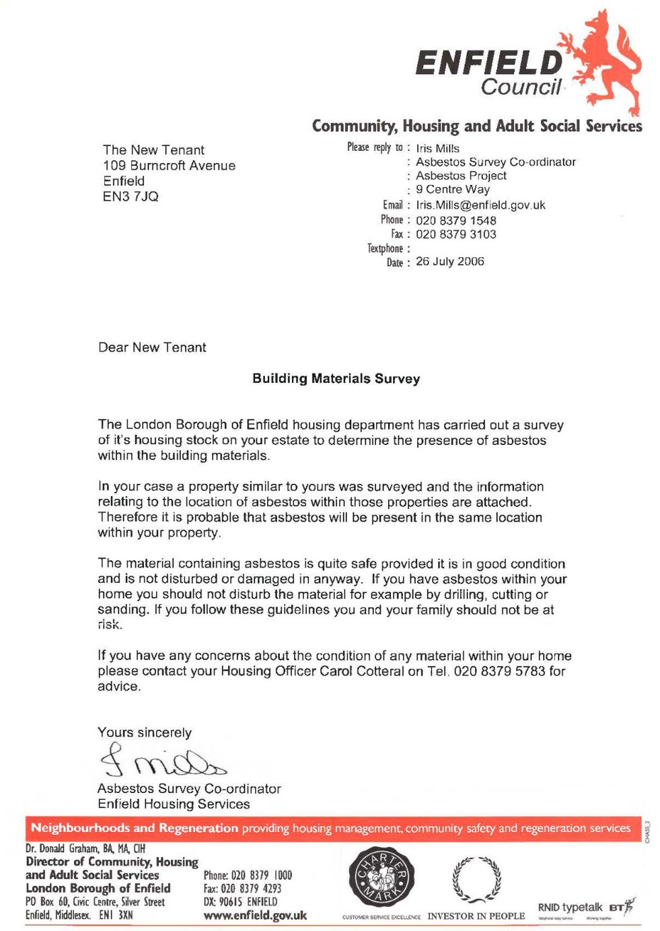
 | Enfield Civic Centre. Enfield Civic Centre. Silver Street, Enfield, London, EN1 3XA | - EXHIBIT D2  - This Exhibit D2 referrers to a letter of evidence made on behalf of the Now Claimant a Mr. S. P. Cordell.  - Document Date 22/11/2011  - This Date 06/10/2022 | 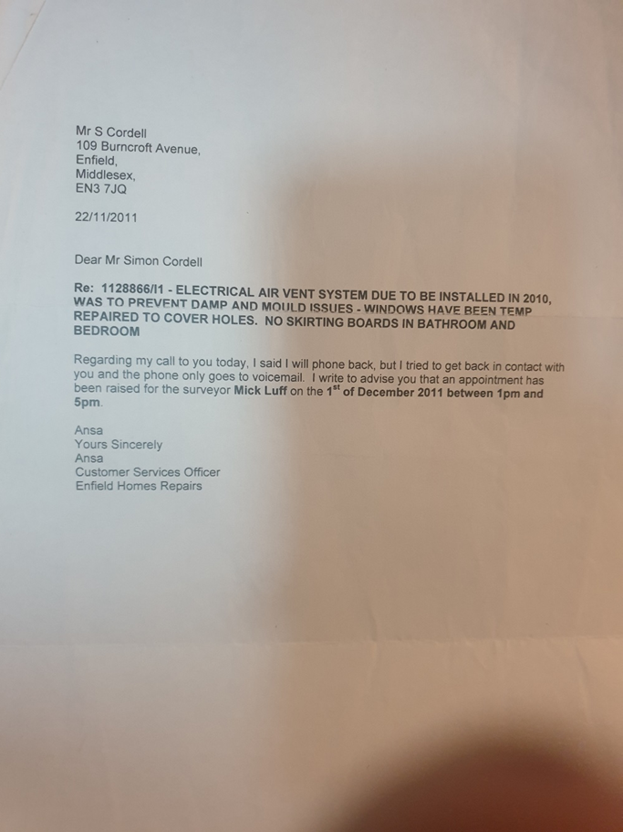
 | Enfield Civic Centre. Enfield Civic Centre. Silver Street, Enfield, London, EN1 3XA | - EXHIBIT D3  - This Exhibit D3 referrers to a letter of evidence made on behalf of the Now Claimant a Mr. S. P. Cordell.  - Document Date 01/12/2011  - This Date 06/10/2022 | 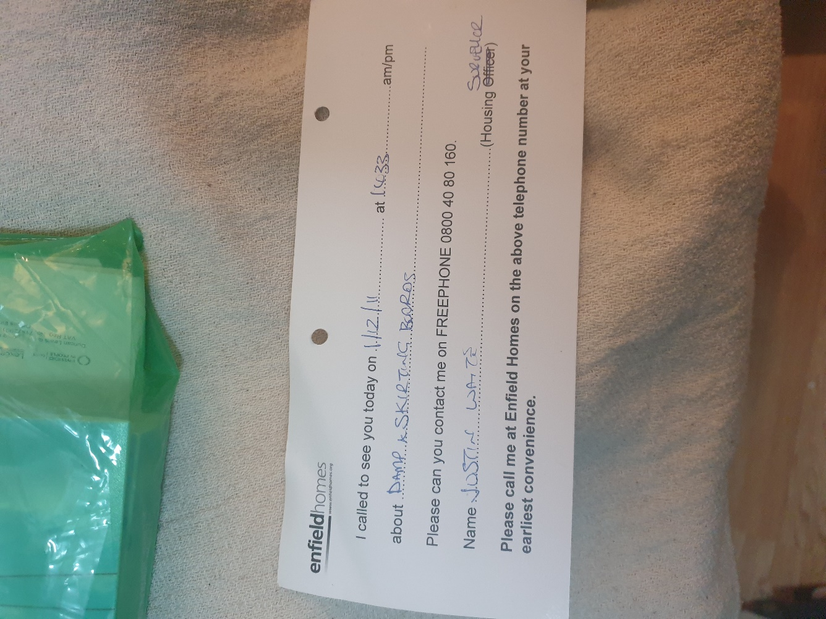
 | Enfield Civic Centre. Enfield Civic Centre. Silver Street, Enfield, London, EN1 3XA | - EXHIBIT D4  - This Exhibit D4 referrers to a letter of evidence made on behalf of the Now Claimant a Mr. S. P. Cordell.  - Document Date 15/02/2012  - This Date 06/10/2022  - Heating | 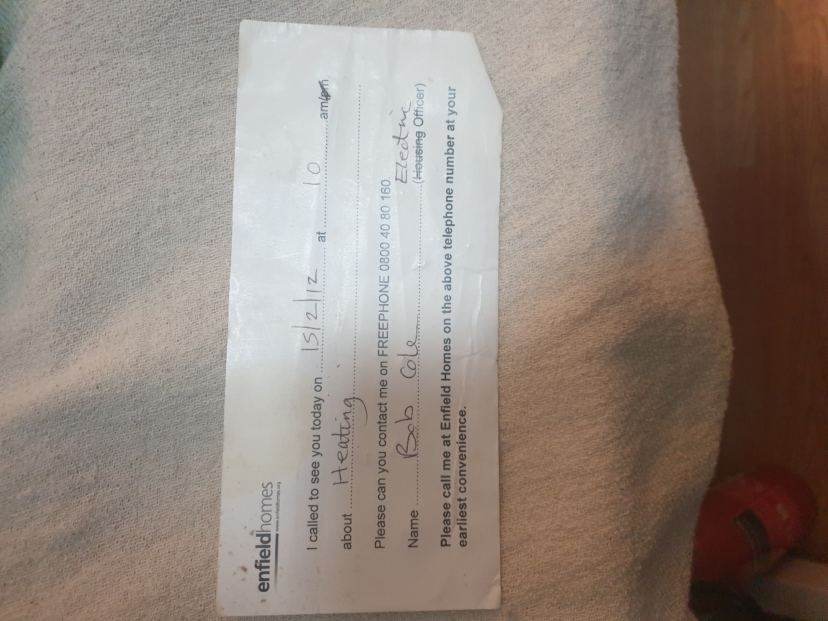
 | Enfield Civic Centre. Enfield Civic Centre. Silver Street, Enfield, London, EN1 3XA | - EXHIBIT D5  - This Exhibit D5 referrers to a letter of evidence made on behalf of the Now Claimant a Mr. S. P. Cordell.  - Total Loss of Gas heating and Hot water in summer 1st May to 31st October.  - Gas defect to domestic gas central Heating appliance.  - Fault Log: 14/05/2009  - Est. Complete Date: 19/05/2009 | 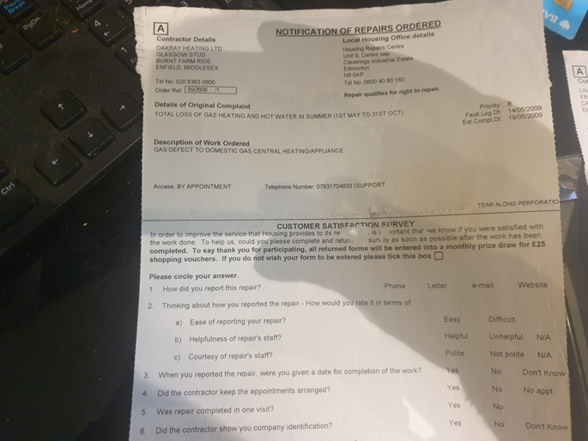
 | Enfield Civic Centre. Enfield Civic Centre. Silver Street, Enfield, London, EN1 3XA | - EXHIBIT D6  - This Exhibit D6 referrers to a letter of evidence made on behalf of the Now Claimant a Mr. S. P. Cordell.  - Access as national grid have shut down the heating system because the CO2 Alarm Kept Sounding.  - Gas defect to domestic gas central Heating appliance.  - Fault Log: 28/11/2014  - Est. Complete Date: 28/11/2014 | 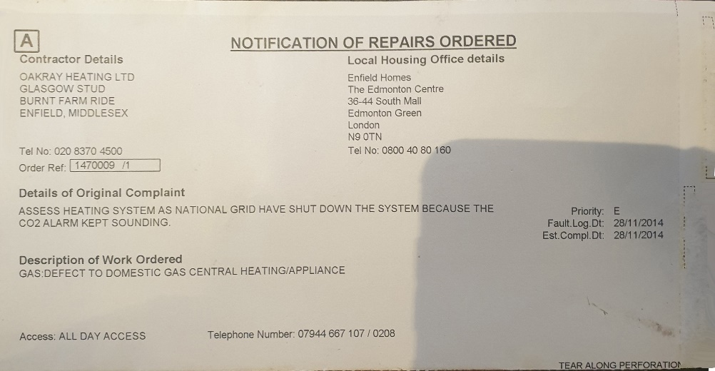
 | Enfield Civic Centre. Enfield Civic Centre. Silver Street, Enfield, London, EN1 3XA | - EXHIBIT D7  - This Exhibit D7 referrers to a letter of evidence made on behalf of the Now Claimant a Mr. S. P. Cordell.  - Supply and fit Graphite Seal  - Gas defect to domestic gas central Heating appliance.  - Fault Log: 01/12/2014  - Est. Complete Date: 03/12/2014 | 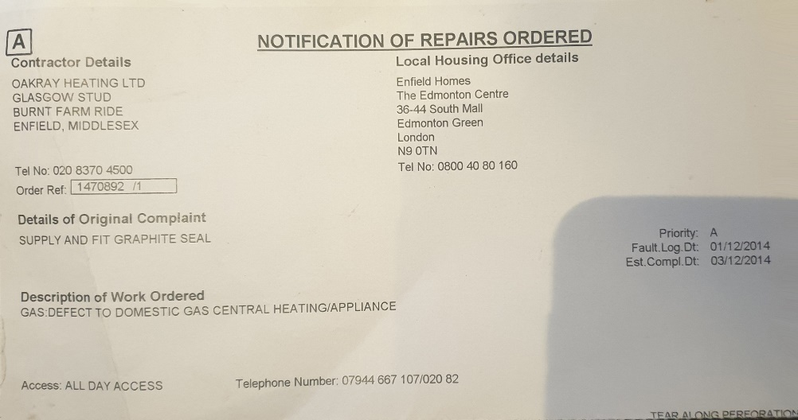
END

Disrepair Issues and Bad Management by My Housing Team Pictures the First Set 109!
[EXHIBIT E]

- File Temp Link Location
- https://horrific-corruption-files.webhop.me/Temp/Disrepair%20109%20Burncroft%20Avenue/

Numb | Details of Responsible Authority / Landlords | Exhibits |  | Photographic Evidence
 | Enfield Civic Centre. Enfield Civic Centre. Silver Street, Enfield, London, EN1 3XA | - EXHIBIT E2  - This EXHIBIT E2 referrers to photographic evidence made on behalf of the Now Claimant a Mr. S. P. Cordell  - This Date 06/10/2022 |  | 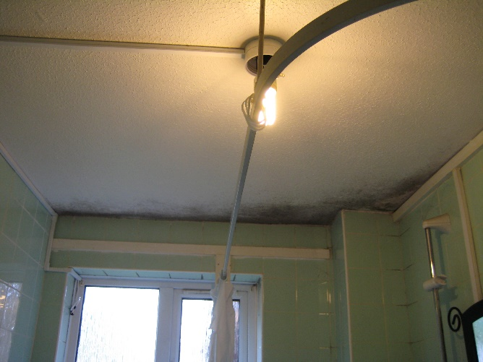
 | Enfield Civic Centre. EN1 3XA | - EXHIBIT E3  - This EXHIBIT E3 referrers to photographic evidence made on behalf of the Now Claimant a Mr. S. P. Cordell  - This Date 06/10/2022 |  | 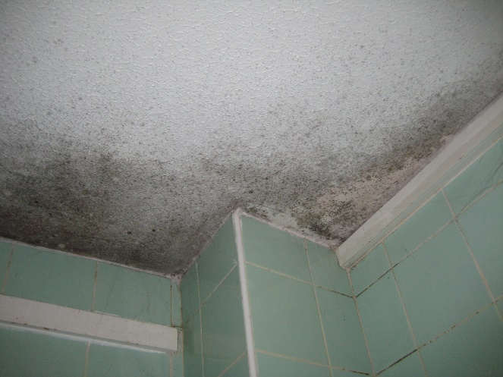
 | Enfield Civic Centre. EN1 3XA | - EXHIBIT E4  - This EXHIBIT E4 referrers to photographic evidence made on behalf of the Now Claimant a Mr. S. P. Cordell  - This Date 06/10/2022 |  | 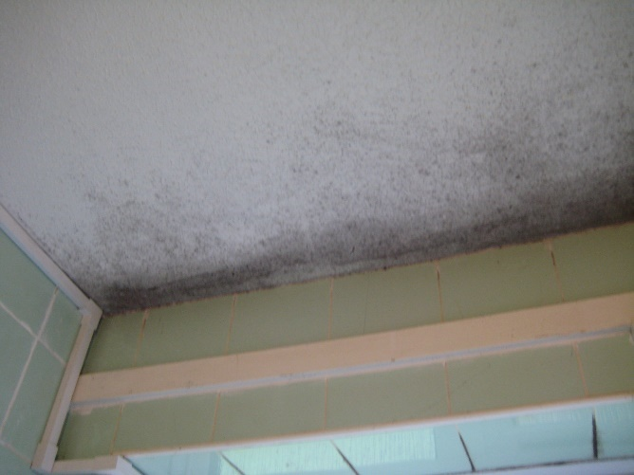
 | Enfield Civic Centre. EN1 3XA | - EXHIBIT E5  - This EXHIBIT E5 referrers to photographic evidence made on behalf of the Now Claimant a Mr. S. P. Cordell  - This Date 06/10/2022 |  | 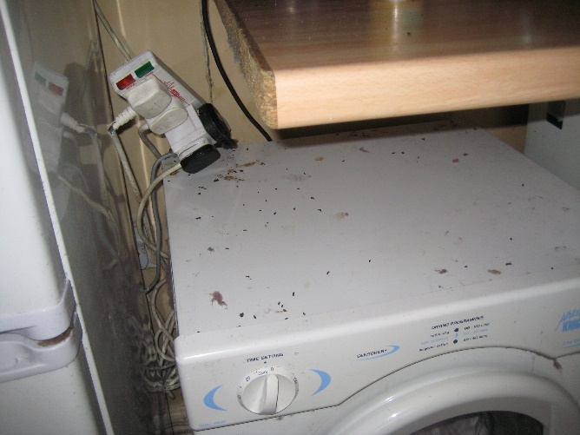
 | Enfield Civic Centre. EN1 3XA | - EXHIBIT E6  - This EXHIBIT E6 referrers to photographic evidence made on behalf of the Now Claimant a Mr. S. P. Cordell  - This Date 06/10/2022 |  | 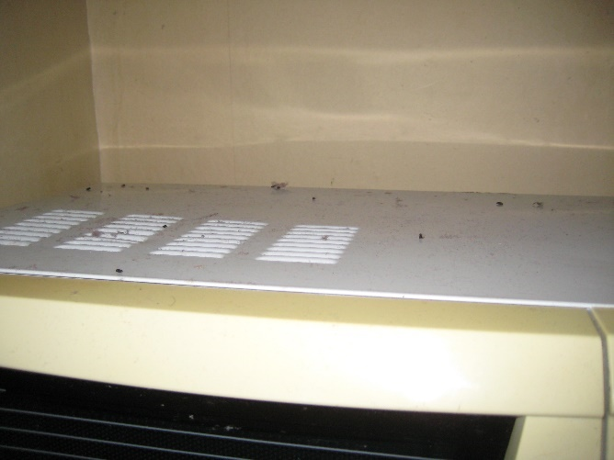
 | Enfield Civic Centre. EN1 3XA | - EXHIBIT E7  - This EXHIBIT E6 referrers to photographic evidence made on behalf of the Now Claimant a Mr. S. P. Cordell  - This Date 06/10/2022 |  | 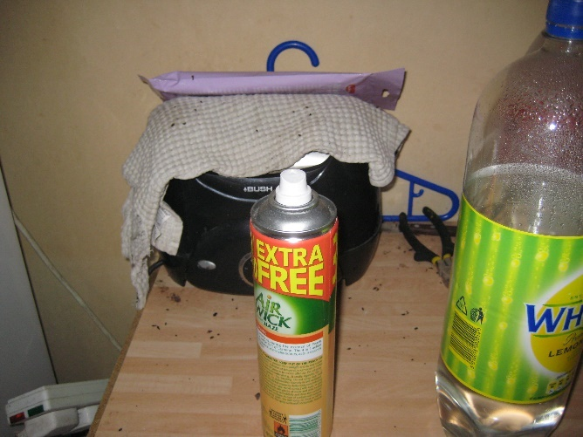
 | Enfield Civic Centre. EN1 3XA | - EXHIBIT E8  - This EXHIBIT E8 referrers to photographic evidence made on behalf of the Now Claimant a Mr. S. P. Cordell  - This Date 06/10/2022 |  | 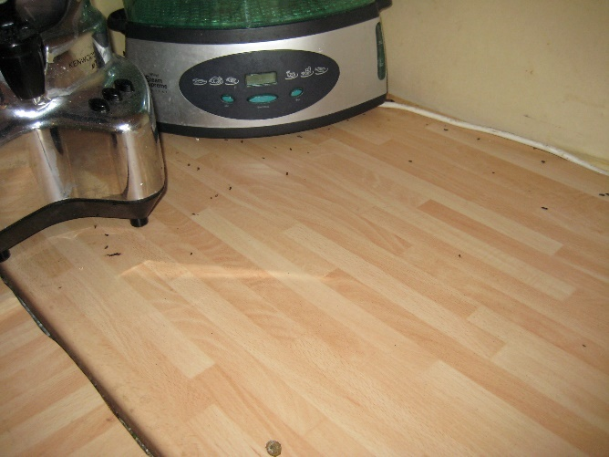
 | Enfield Civic Centre. EN1 3XA | - EXHIBIT E9  - This EXHIBIT E9 referrers to photographic evidence made on behalf of the Now Claimant a Mr. S. P. Cordell  - This Date 06/10/2022 |  | 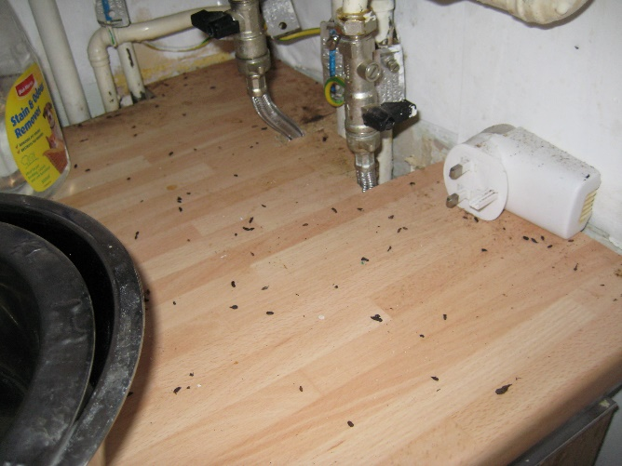
 | Enfield Civic Centre. EN1 3XA | - EXHIBIT E10  - This EXHIBIT E10 referrers to photographic evidence made on behalf of the Now Claimant a Mr. S. P. Cordell  - This Date 06/10/2022 |  | 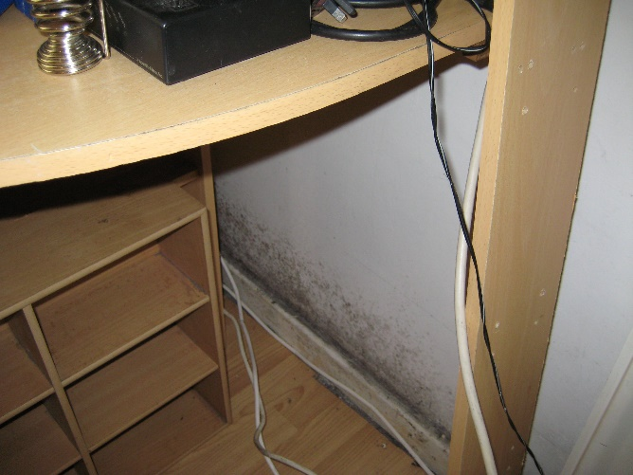
 | Enfield Civic Centre. EN1 3XA | - EXHIBIT E11  - This EXHIBIT E11 referrers to photographic evidence made on behalf of the Now Claimant a Mr. S. P. Cordell  - This Date 06/10/2022 |  | 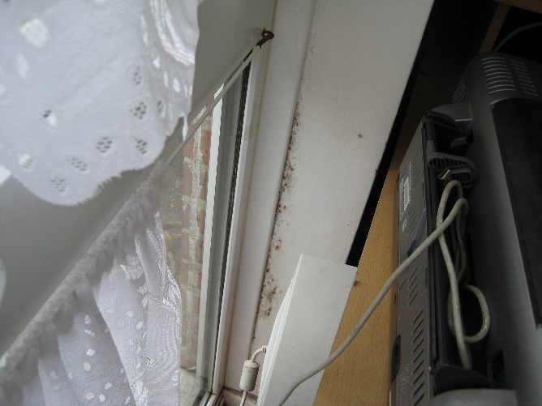
 | Enfield Civic Centre. EN1 3XA | - EXHIBIT E12  - This EXHIBIT E12 referrers to photographic evidence made on behalf of the Now Claimant a Mr. S. P. Cordell  - This Date 06/10/2022 |  | 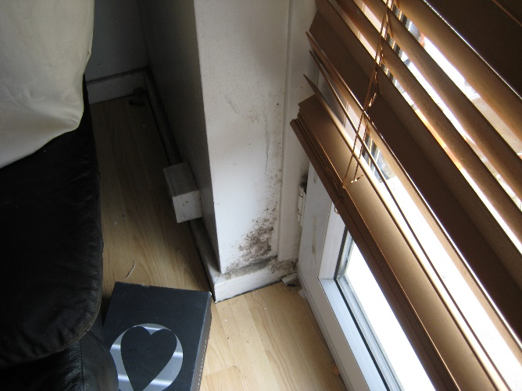
 | Enfield Civic Centre. EN1 3XA | - EXHIBIT E13  - This EXHIBIT E13 referrers to photographic evidence made on behalf of the Now Claimant a Mr. S. P. Cordell  - This Date 06/10/2022 |  | 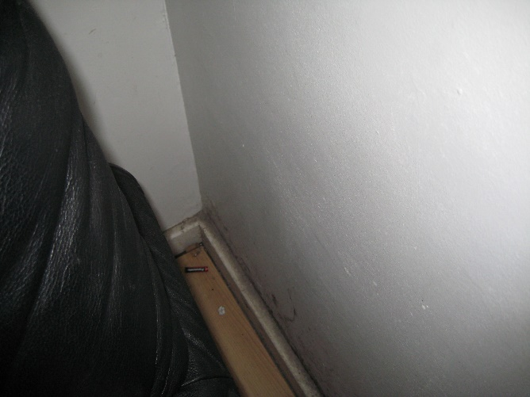
 | Enfield Civic Centre. EN1 3XA | - EXHIBIT E14  - This EXHIBIT E14 referrers to photographic evidence made on behalf of the Now Claimant a Mr. S. P. Cordell  - This Date 06/10/2022 |  | 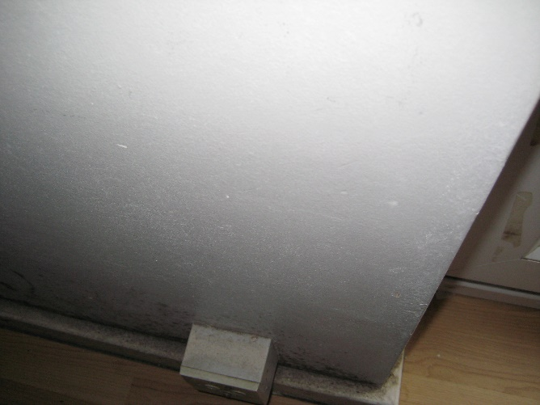
 | Enfield Civic Centre. EN1 3XA | - EXHIBIT E15  - This EXHIBIT E15 referrers to photographic evidence made on behalf of the Now Claimant a Mr. S. P. Cordell  - This Date 06/10/2022 |  | 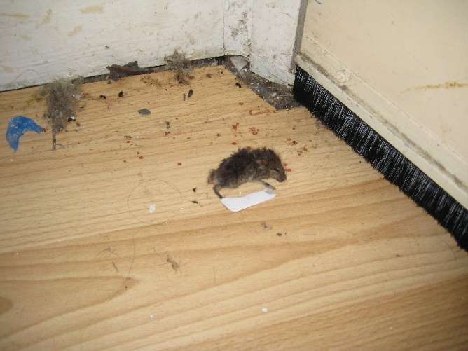
 | Enfield Civic Centre. EN1 3XA | - EXHIBIT E16  - This EXHIBIT E16 referrers to photographic evidence made on behalf of the Now Claimant a Mr. S. P. Cordell  - This Date 06/10/2022 |  | 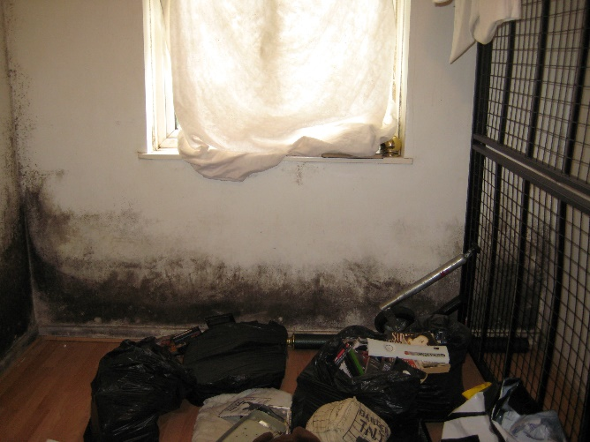
 | Enfield Civic Centre. EN1 3XA | - EXHIBIT E17  - This EXHIBIT E17 referrers to photographic evidence made on behalf of the Now Claimant a Mr. S. P. Cordell  - This Date 06/10/2022 |  | 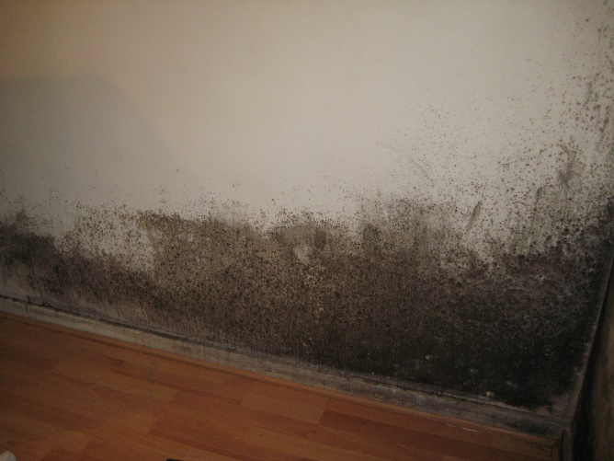
 | Enfield Civic Centre. EN1 3XA | - EXHIBIT E18  - This EXHIBIT E18 referrers to photographic evidence made on behalf of the Now Claimant a Mr. S. P. Cordell  - This Date 06/10/2022 |  | 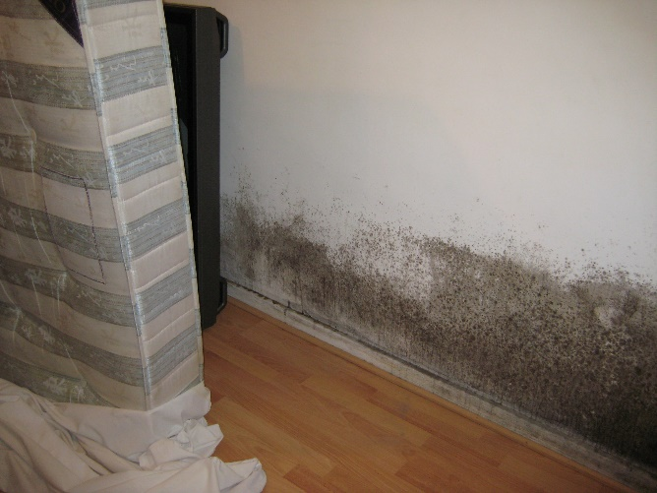
 | Enfield Civic Centre. EN1 3XA | - EXHIBIT E19  - This EXHIBIT E19 referrers to photographic evidence made on behalf of the Now Claimant a Mr. S. P. Cordell  - This Date 06/10/2022 |  | 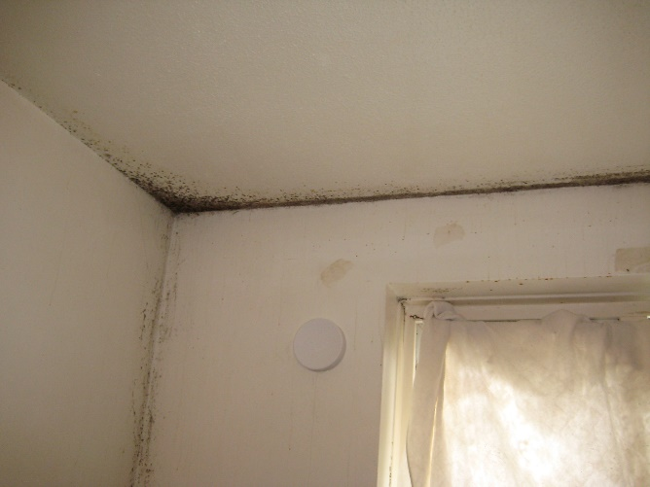
 | Enfield Civic Centre. EN1 3XA | - EXHIBIT E20  - This EXHIBIT E20 referrers to photographic evidence made on behalf of the Now Claimant a Mr. S. P. Cordell  - This Date 06/10/2022 |  | 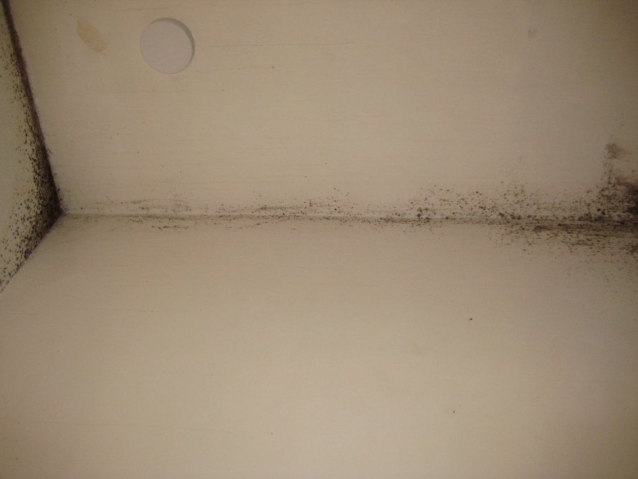
 | Enfield Civic Centre. EN1 3XA | - EXHIBIT E21  - This EXHIBIT E21 referrers to photographic evidence made on behalf of the Now Claimant a Mr. S. P. Cordell  - This Date 06/10/2022 |  | 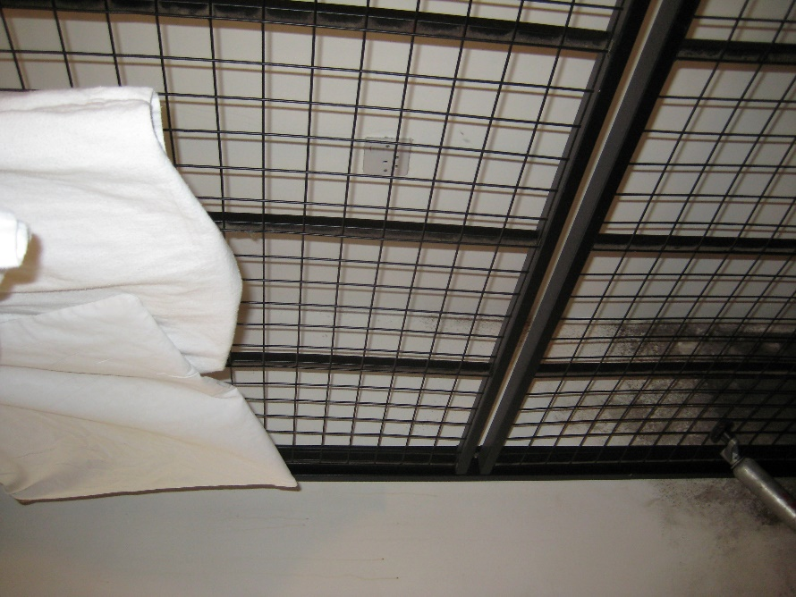
 | Enfield Civic Centre. EN1 3XA | - EXHIBIT E22  - This EXHIBIT E22 referrers to photographic evidence made on behalf of the Now Claimant a Mr. S. P. Cordell  - This Date 06/10/2022 |  | 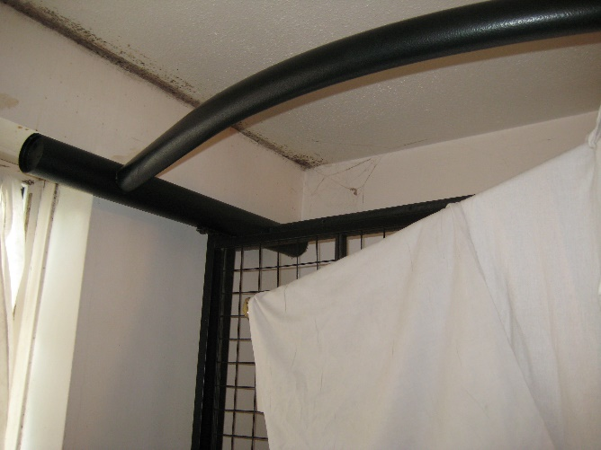
 | Enfield Civic Centre. EN1 3XA | - EXHIBIT E23  - This EXHIBIT E23 referrers to photographic evidence made on behalf of the Now Claimant a Mr. S. P. Cordell  - This Date 06/10/2022 |  | 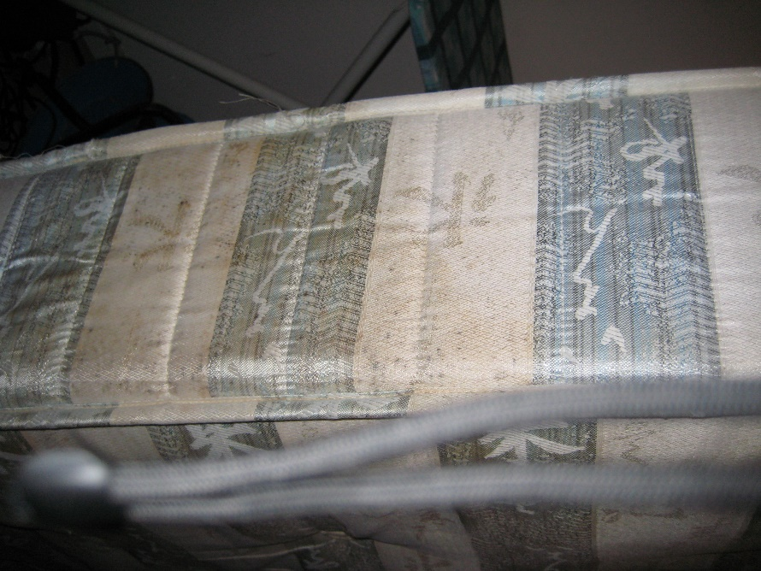
 | Enfield Civic Centre. EN1 3XA | - EXHIBIT E24  - This EXHIBIT E24 referrers to photographic evidence made on behalf of the Now Claimant a Mr. S. P. Cordell  - This Date 06/10/2022 |  | 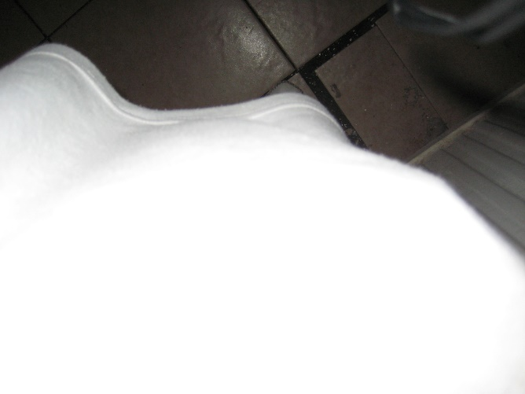
 | Enfield Civic Centre. EN1 3XA | - EXHIBIT E25  - This EXHIBIT E25 referrers to photographic evidence made on behalf of the Now Claimant a Mr. S. P. Cordell  - This Date 06/10/2022
End

Disrepair Issues and Bad Management by My Housing Team 117 Burncroft Avenue Flat and Block Pictures!
[EXHIBIT F]

- File Temp Link Location
- https://horrific-corruption-files.webhop.me/Temp/Disrepair%20109%20Burncroft%20Avenue/

Numb | Details of Responsible Authority / Landlords | Exhibits |  | Photographic Evidence
 | Enfield Civic Centre. Enfield Civic Centre. Silver Street, Enfield, London, EN1 3XA | - EXHIBIT F27  - This EXHIBIT F27 referrers to photographic evidence made on behalf of the Now Claimant a Mr. S. P. Cordell  - This Date 06/10/2022 | This just come out of 117 Burncroft Avenue.  ‎25 ‎May ‎2022?  set of tennants in 2 years or more | 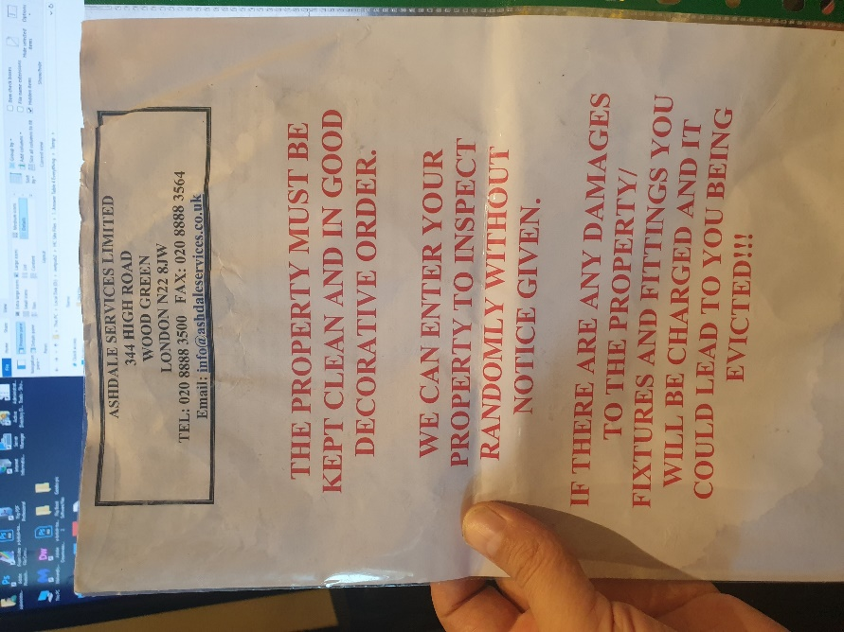
 | Enfield Civic Centre. Enfield Civic Centre. Silver Street, Enfield, London, EN1 3XA | - EXHIBIT F28  - This EXHIBIT F28 referrers to photographic evidence made on behalf of the Now Claimant a Mr. S. P. Cordell  - This Date 06/10/2022 |  | 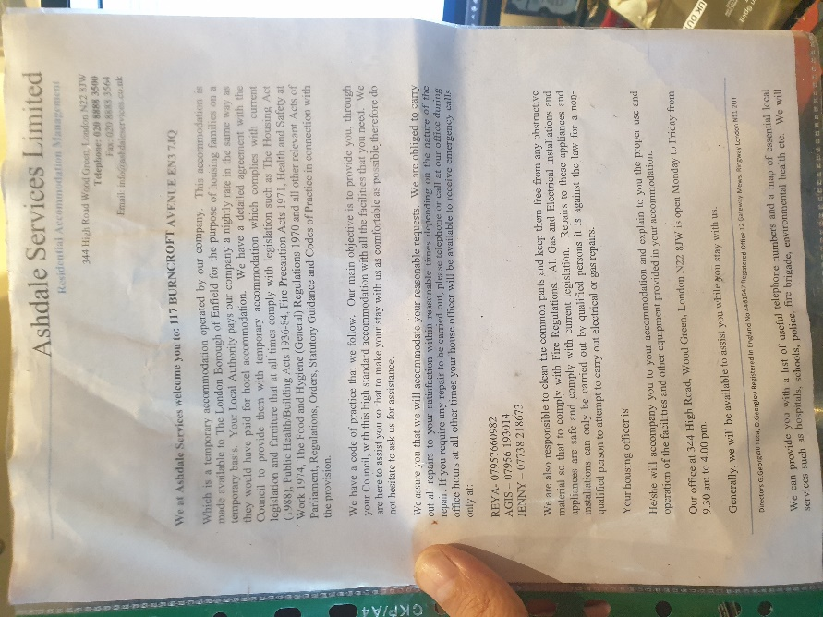
 | Enfield Civic Centre. Enfield Civic Centre. Silver Street, Enfield, London, EN1 3XA | - EXHIBIT F29  - This EXHIBIT F29 referrers to photographic evidence made on behalf of the Now Claimant a Mr. S. P. Cordell  - This Date 06/10/2022 |  | 
 | Enfield Civic Centre. Enfield Civic Centre. Silver Street, Enfield, London, EN1 3XA | - EXHIBIT F30  - This EXHIBIT F30 referrers to photographic evidence made on behalf of the Now Claimant a Mr. S. P. Cordell  - This Date 06/10/2022 |  | 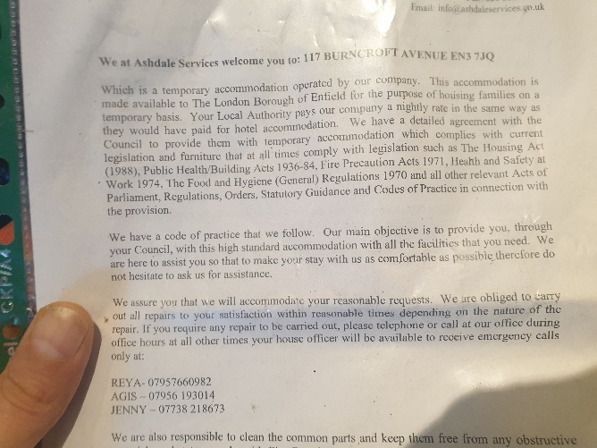
 | Enfield Civic Centre. Enfield Civic Centre. Silver Street, Enfield, London, EN1 3XA | - EXHIBIT F31  - This EXHIBIT F31 referrers to photographic evidence made on behalf of the Now Claimant a Mr. S. P. Cordell  - This Date 06/10/2022 |  | Video Link  https://horrific-corruption-files.webhop.me/Temp/Disrepair%20109%20Burncroft%20Avenue/1%20This%20just%20come%20out%20of%20117%203rd%20set%20of%20tennants%20in%202%20years%20or%20more/20220525_175017.mp4
 | Enfield Civic Centre. Enfield Civic Centre. Silver Street, Enfield, London, EN1 3XA | - EXHIBIT F32  - This EXHIBIT F32 referrers to photographic evidence made on behalf of the Now Claimant a Mr. S. P. Cordell  - This Date 06/10/2022 |  | Video Link  https://horrific-corruption-files.webhop.me/Temp/Disrepair%20109%20Burncroft%20Avenue/1%20This%20just%20come%20out%20of%20117%203rd%20set%20of%20tennants%20in%202%20years%20or%20more/20220525_175620.mp4
 | Enfield Civic Centre. Enfield Civic Centre. Silver Street, Enfield, London, EN1 3XA | - EXHIBIT F33  - This EXHIBIT F33 referrers to photographic evidence made on behalf of the Now Claimant a Mr. S. P. Cordell  - This Date 06/10/2022 | Video Link Pictures | 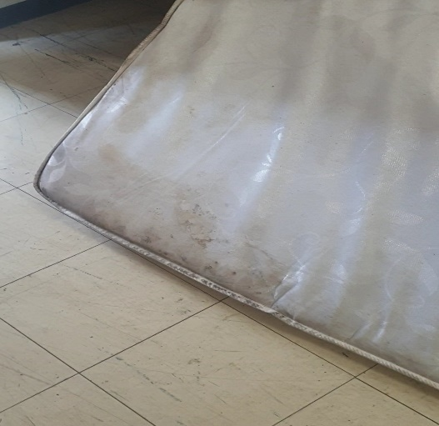
 | Enfield Civic Centre. Enfield Civic Centre. Silver Street, Enfield, London, EN1 3XA | - EXHIBIT F34  - This EXHIBIT F34 referrers to photographic evidence made on behalf of the Now Claimant a Mr. S. P. Cordell  - This Date 06/10/2022 |  | 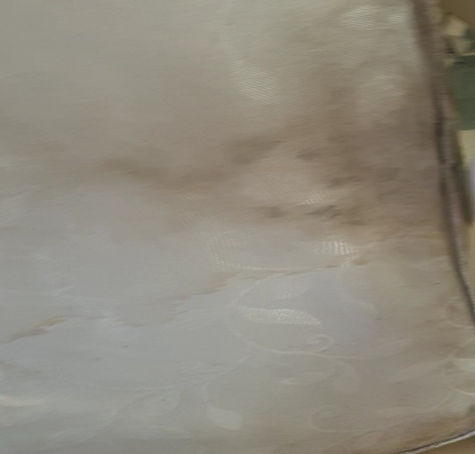
 | Enfield Civic Centre. Enfield Civic Centre. Silver Street, Enfield, London, EN1 3XA | - EXHIBIT F35  - This EXHIBIT F35 referrers to photographic evidence made on behalf of the Now Claimant a Mr. S. P. Cordell  - This Date 06/10/2022 |  | 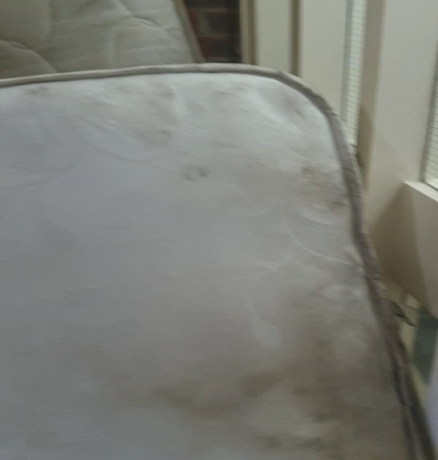
 | Enfield Civic Centre. Enfield Civic Centre. Silver Street, Enfield, London, EN1 3XA | - EXHIBIT F36  - This EXHIBIT F36 referrers to photographic evidence made on behalf of the Now Claimant a Mr. S. P. Cordell  - This Date 06/10/2022 |  | 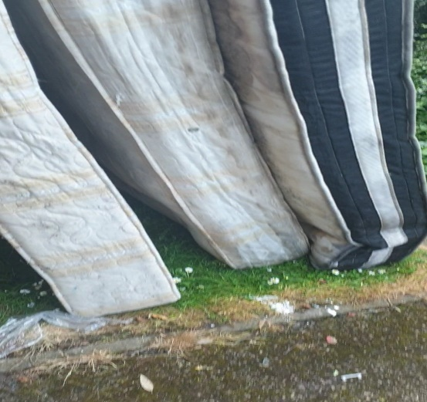
 | Enfield Civic Centre. Enfield Civic Centre. Silver Street, Enfield, London, EN1 3XA | - EXHIBIT F37  - This EXHIBIT F37 referrers to photographic evidence made on behalf of the Now Claimant a Mr. S. P. Cordell  - This Date 06/10/2022 |  | 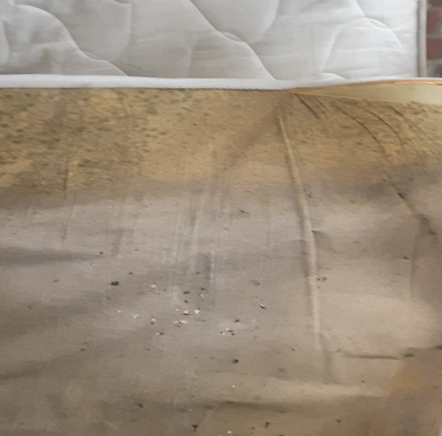
 | Enfield Civic Centre. Enfield Civic Centre. Silver Street, Enfield, London, EN1 3XA | - EXHIBIT F38  - This EXHIBIT F38 referrers to photographic evidence made on behalf of the Now Claimant a Mr. S. P. Cordell  - This Date 06/10/2022 |  | 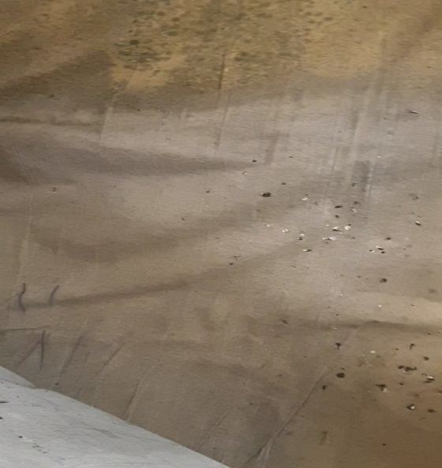
 | Enfield Civic Centre. Enfield Civic Centre. Silver Street, Enfield, London, EN1 3XA | - EXHIBIT F39  - This EXHIBIT F39 referrers to photographic evidence made on behalf of the Now Claimant a Mr. S. P. Cordell  - This Date 06/10/2022 |  | 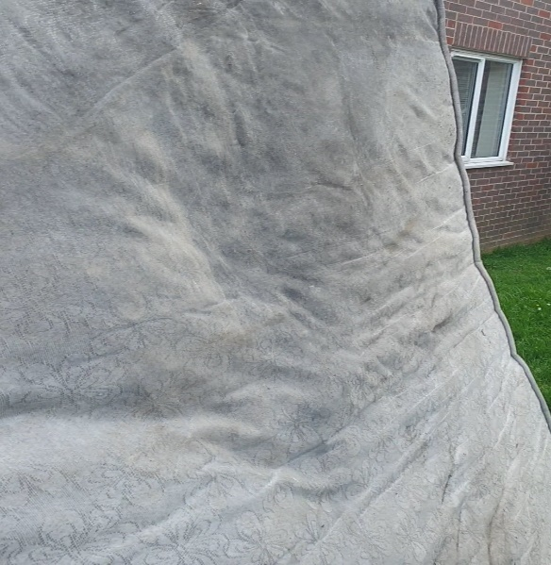
 | Enfield Civic Centre. Enfield Civic Centre. Silver Street, Enfield, London, EN1 3XA | - EXHIBIT F40  - This EXHIBIT F40 referrers to photographic evidence made on behalf of the Now Claimant a Mr. S. P. Cordell  - This Date 06/10/2022 |  | 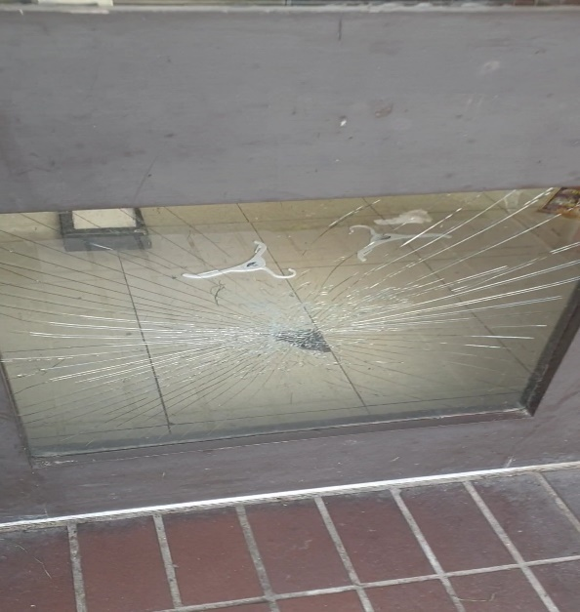
 | Enfield Civic Centre. Enfield Civic Centre. Silver Street, Enfield, London, EN1 3XA | - EXHIBIT F41  - This EXHIBIT F41 referrers to photographic evidence made on behalf of the Now Claimant a Mr. S. P. Cordell  - This Date 06/10/2022
END

Disrepair Issues and Bad Management by My Housing Team Pictures the Second Set 109!
EXHIBIT G

- File Temp Link Location
- https://horrific-corruption-files.webhop.me/Temp/Disrepair%20109%20Burncroft%20Avenue/

Numb | Details of Responsible Authority / Landlords | Exhibits |  | Photographic Evidence
 | Enfield Civic Centre. Enfield Civic Centre. Silver Street, Enfield, London, EN1 3XA | - EXHIBIT G42  - This EXHIBIT G42 referrers to photographic evidence made on behalf of the Now Claimant a Mr. S. P. Cordell  - This Date 06/10/2022 | Upto date of the 06/10/2022 | 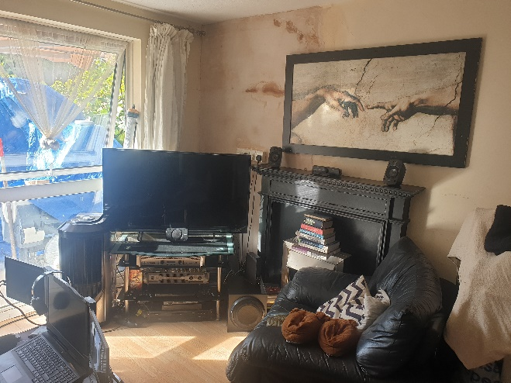
 | Enfield Civic Centre. Enfield Civic Centre. Silver Street, Enfield, London, EN1 3XA | - EXHIBIT G43  - This EXHIBIT G43 referrers to photographic evidence made on behalf of the Now Claimant a Mr. S. P. Cordell  - This Date 06/10/2022 | Upto date of the 06/10/2022 | 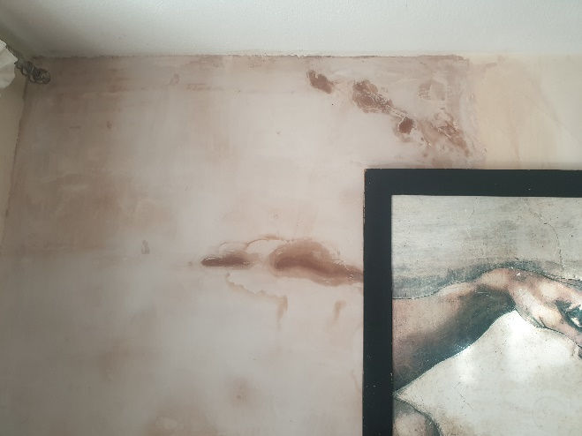
 | Enfield Civic Centre. Enfield Civic Centre. Silver Street, Enfield, London, EN1 3XA | - EXHIBIT G44  - This EXHIBIT G44 referrers to photographic evidence made on behalf of the Now Claimant a Mr. S. P. Cordell  - This Date 06/10/2022 | Upto date of the 06/10/2022 | 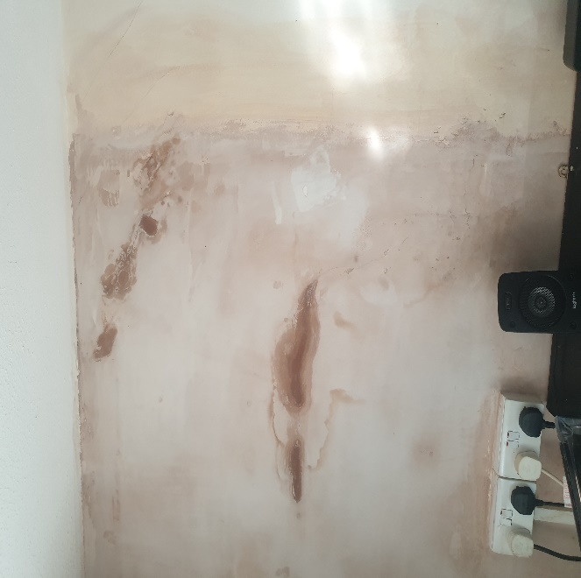
 | Enfield Civic Centre. Enfield Civic Centre. Silver Street, Enfield, London, EN1 3XA | - EXHIBIT G45  - This EXHIBIT G45 referrers to photographic evidence made on behalf of the Now Claimant a Mr. S. P. Cordell  - This Date 06/10/2022 | Upto date of the 06/10/2022 | 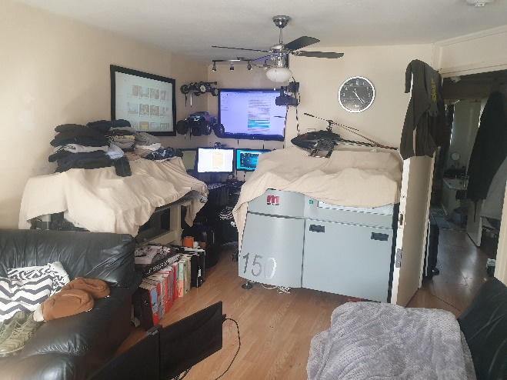
 | Enfield Civic Centre. Enfield Civic Centre. Silver Street, Enfield, London, EN1 3XA | - EXHIBIT G46  - This EXHIBIT G46 referrers to photographic evidence made on behalf of the Now Claimant a Mr. S. P. Cordell  - This Date 06/10/2022 | Upto date of the 06/10/2022 | 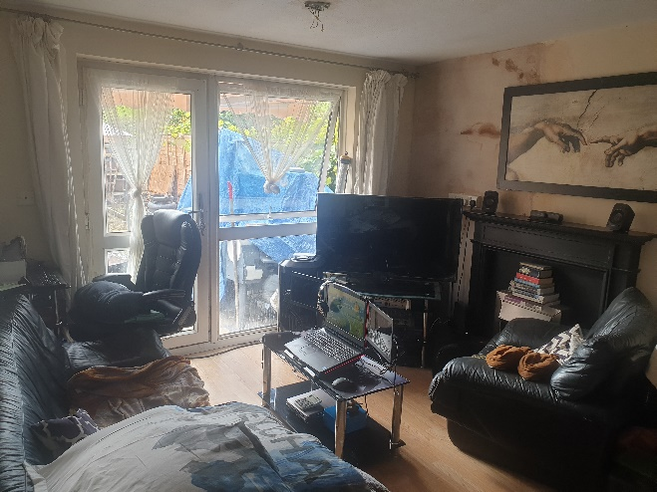
 | Enfield Civic Centre. Enfield Civic Centre. Silver Street, Enfield, London, EN1 3XA | - EXHIBIT G47  - This EXHIBIT G47 referrers to photographic evidence made on behalf of the Now Claimant a Mr. S. P. Cordell  - This Date 06/10/2022 | Upto date of the 06/10/2022 | 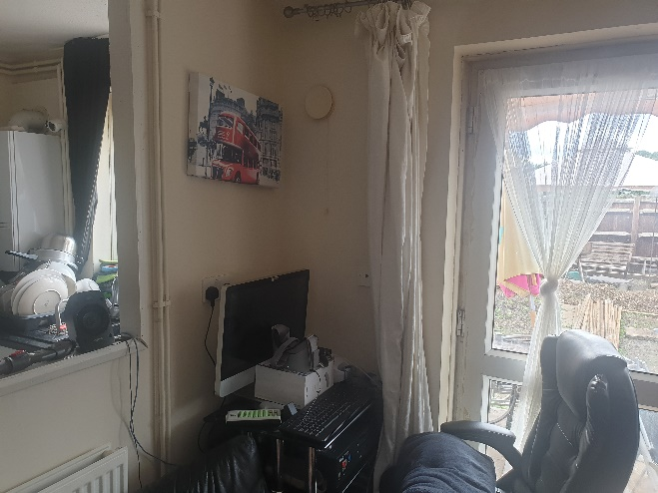
 | Enfield Civic Centre. Enfield Civic Centre. Silver Street, Enfield, London, EN1 3XA | - EXHIBIT G48  - This EXHIBIT G48 referrers to photographic evidence made on behalf of the Now Claimant a Mr. S. P. Cordell  - This Date 06/10/2022 | Upto date of the 06/10/2022 | 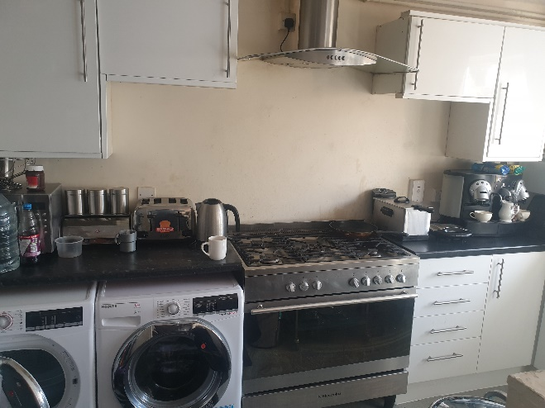
 | Enfield Civic Centre. Enfield Civic Centre. Silver Street, Enfield, London, EN1 3XA | - EXHIBIT G49  - This EXHIBIT G49 referrers to photographic evidence made on behalf of the Now Claimant a Mr. S. P. Cordell  - This Date 06/10/2022 | Upto date of the 06/10/2022 | 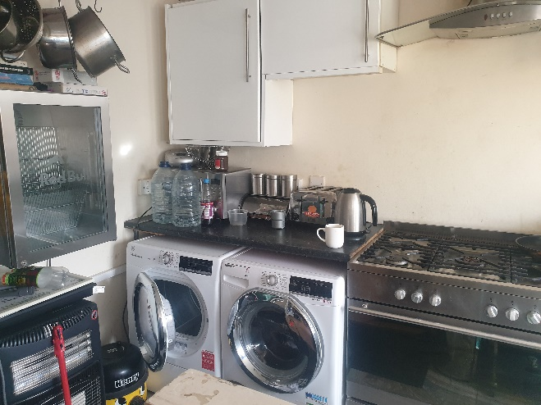
 | Enfield Civic Centre. Enfield Civic Centre. Silver Street, Enfield, London, EN1 3XA | - EXHIBIT G50  - This EXHIBIT G50 referrers to photographic evidence made on behalf of the Now Claimant a Mr. S. P. Cordell  - This Date 06/10/2022 | Upto date of the 06/10/2022 | 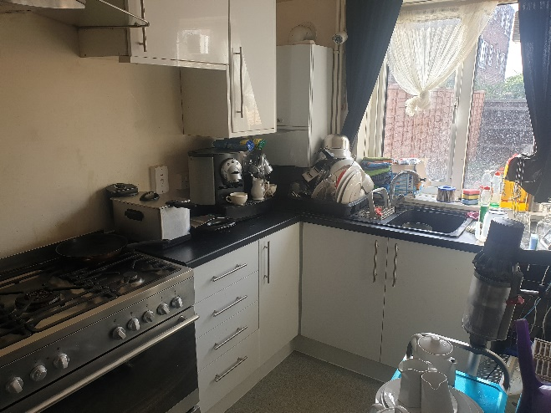
 | Enfield Civic Centre. Enfield Civic Centre. Silver Street, Enfield, London, EN1 3XA | - EXHIBIT G51  - This EXHIBIT G51 referrers to photographic evidence made on behalf of the Now Claimant a Mr. S. P. Cordell  - This Date 06/10/2022 | Upto date of the 06/10/2022 | 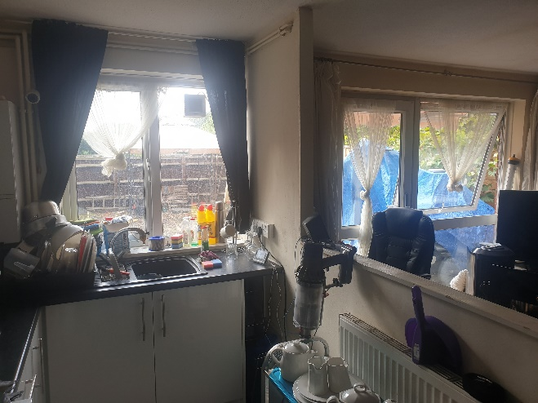
 | Enfield Civic Centre. Enfield Civic Centre. Silver Street, Enfield, London, EN1 3XA | - EXHIBIT G52  - This EXHIBIT G52 referrers to photographic evidence made on behalf of the Now Claimant a Mr. S. P. Cordell  - This Date 06/10/2022 | Upto date of the 06/10/2022 | 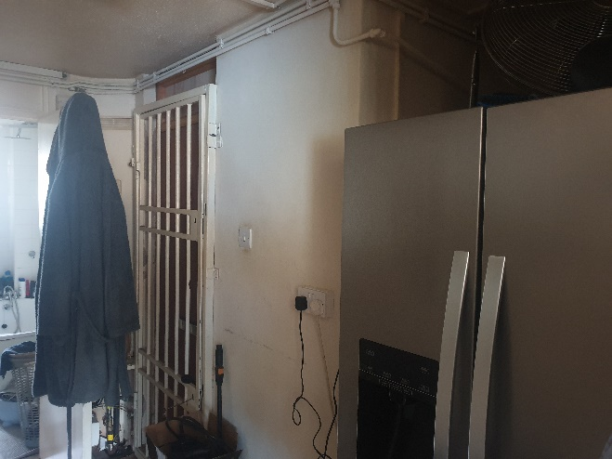
 | Enfield Civic Centre. Enfield Civic Centre. Silver Street, Enfield, London, EN1 3XA | - EXHIBIT G53  - This EXHIBIT G53 referrers to photographic evidence made on behalf of the Now Claimant a Mr. S. P. Cordell  - This Date 06/10/2022 | Upto date of the 06/10/2022 | 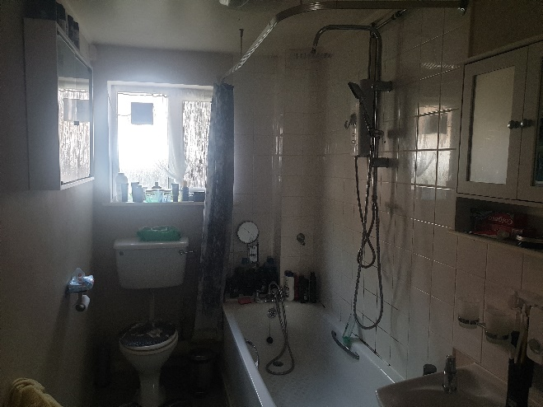
 | Enfield Civic Centre. Enfield Civic Centre. Silver Street, Enfield, London, EN1 3XA | - EXHIBIT G54  - This EXHIBIT G54 referrers to photographic evidence made on behalf of the Now Claimant a Mr. S. P. Cordell  - This Date 06/10/2022 | Upto date of the 06/10/2022 | 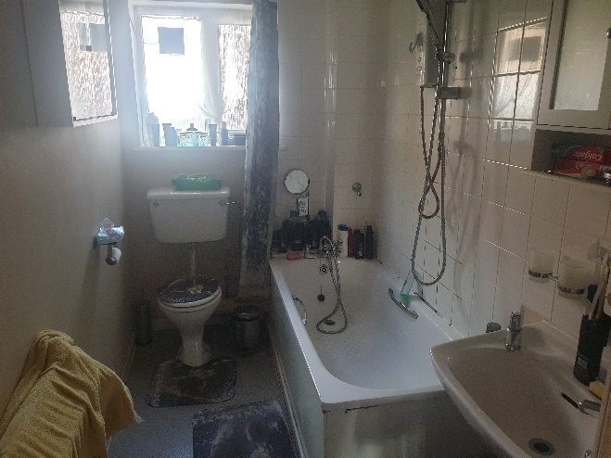
 | Enfield Civic Centre. Enfield Civic Centre. Silver Street, Enfield, London, EN1 3XA | - EXHIBIT G55  - This EXHIBIT G55 referrers to photographic evidence made on behalf of the Now Claimant a Mr. S. P. Cordell  - This Date 06/10/2022 | Upto date of the 06/10/2022 | 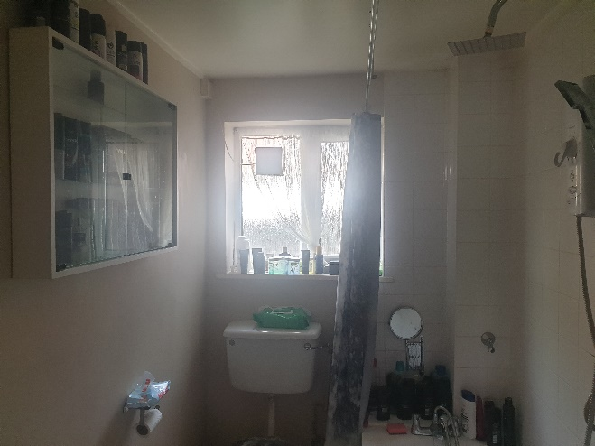
 | Enfield Civic Centre. Enfield Civic Centre. Silver Street, Enfield, London, EN1 3XA | - EXHIBIT G56  - This EXHIBIT G56 referrers to photographic evidence made on behalf of the Now Claimant a Mr. S. P. Cordell  - This Date 06/10/2022 | Upto date of the 06/10/2022 | 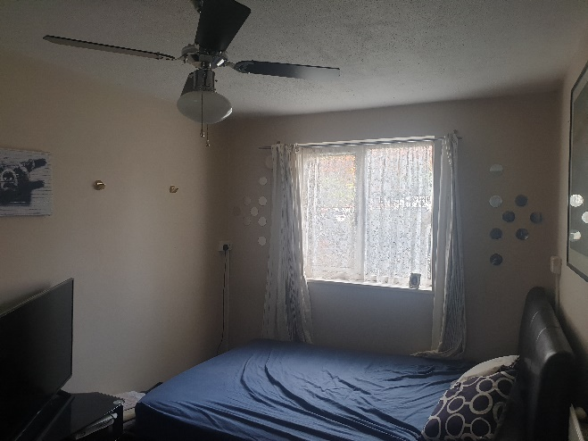
 | Enfield Civic Centre. Enfield Civic Centre. Silver Street, Enfield, London, EN1 3XA | - EXHIBIT G57  - This EXHIBIT G57 referrers to photographic evidence made on behalf of the Now Claimant a Mr. S. P. Cordell  - This Date 06/10/2022 | Upto date of the 06/10/2022 | 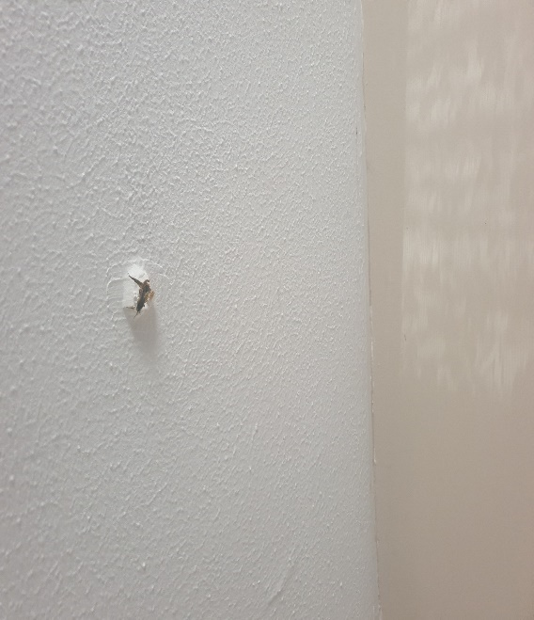
 | Enfield Civic Centre. Enfield Civic Centre. Silver Street, Enfield, London, EN1 3XA | - EXHIBIT G58  - This EXHIBIT G58 referrers to photographic evidence made on behalf of the Now Claimant a Mr. S. P. Cordell  - This Date 06/10/2022 | Upto date of the 06/10/2022 | 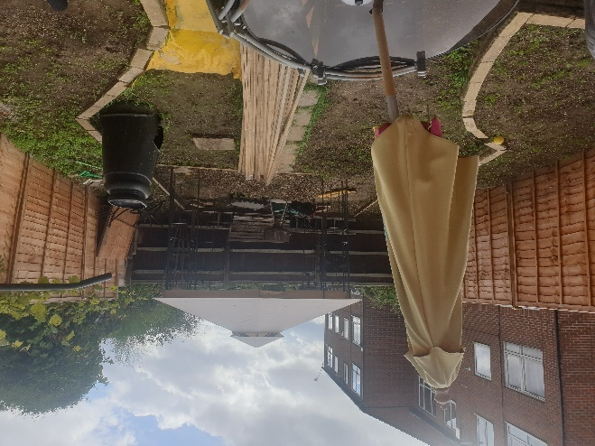
 | Enfield Civic Centre. Enfield Civic Centre. Silver Street, Enfield, London, EN1 3XA | - EXHIBIT G59  - This EXHIBIT G59 referrers to photographic evidence made on behalf of the Now Claimant a Mr. S. P. Cordell  - This Date 06/10/2022 | Upto date of the 06/10/2022 | 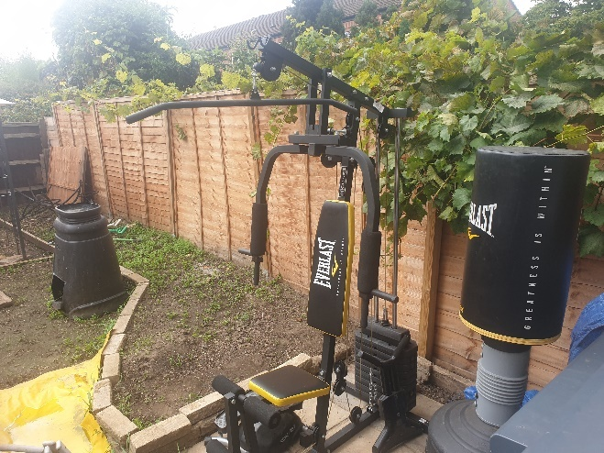
 | Enfield Civic Centre. Enfield Civic Centre. Silver Street, Enfield, London, EN1 3XA | - EXHIBIT G60  - This EXHIBIT G60 referrers to photographic evidence made on behalf of the Now Claimant a Mr. S. P. Cordell  - This Date 06/10/2022 | Upto date of the 06/10/2022 | 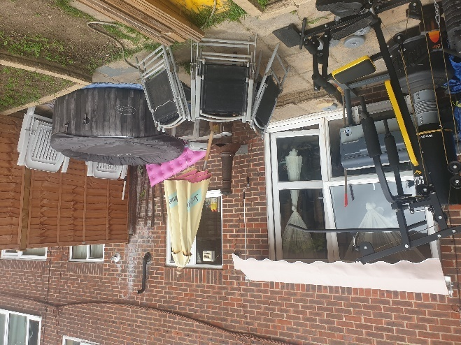
 | Enfield Civic Centre. Enfield Civic Centre. Silver Street, Enfield, London, EN1 3XA | - EXHIBIT G61  - This EXHIBIT G61 referrers to photographic evidence made on behalf of the Now Claimant a Mr. S. P. Cordell  - This Date 06/10/2022 | Upto date of the 06/10/2022 | 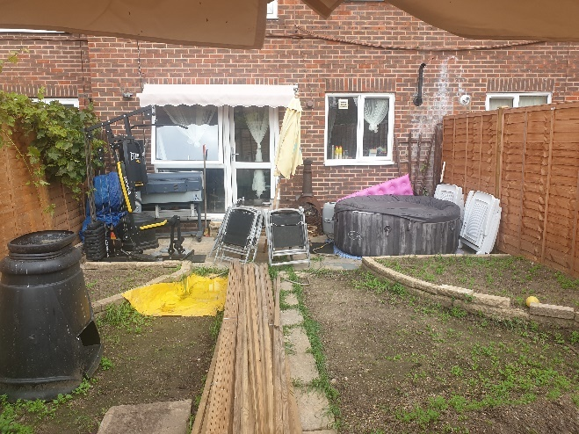
 | Enfield Civic Centre. Enfield Civic Centre. Silver Street, Enfield, London, EN1 3XA | - EXHIBIT G62  - This EXHIBIT G62 referrers to photographic evidence made on behalf of the Now Claimant a Mr. S. P. Cordell  - This Date 06/10/2022 | Upto date of the 06/10/2022 | 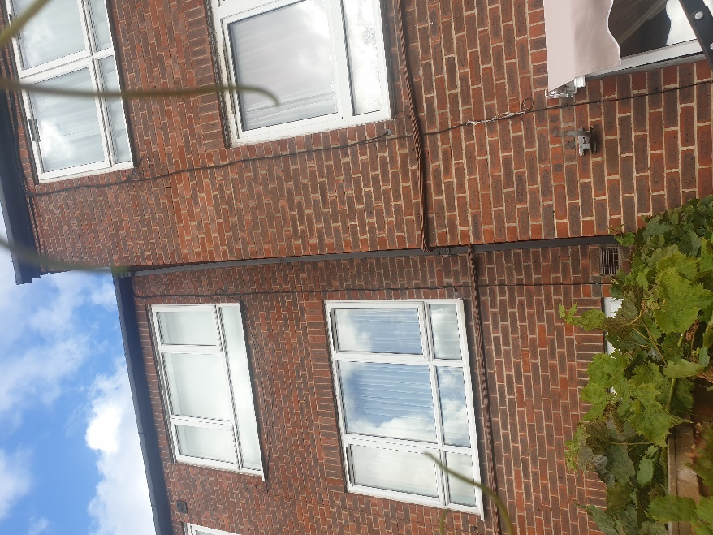
 | Enfield Civic Centre. Enfield Civic Centre. Silver Street, Enfield, London, EN1 3XA | - EXHIBIT G63  - This EXHIBIT G63 referrers to photographic evidence made on behalf of the Now Claimant a Mr. S. P. Cordell  - This Date 06/10/2022 | Upto date of the 06/10/2022

